

**Assignment Report**

**INFO 13013**

Group project (Web Development)

**Content**

**1.Introduction**

**2.Group members**

**3.Home page**

**4.About us page**

1. Our vision and mission
2. Department history

**5.Citizenship page**

1. General information
2. Overseas birth registration

**6.Passports page**

**7.RTI page**

**8.Contact us page**

**9.CSS**

# 1.Introduction

We are presenting here about the immigration and emigration of Sri Lanka. Eight members in our group.

2.Group members

1. HS/2019/0209 – H.A.N. Dhanushani - Group Leader
2. HS/2020/0421 – M.L.D. Lakmali
3. HS/2020/1172 – J.C.K. LAKSHAN
4. HS/2020/0619 – W.N.R. WIJESINGHE
5. HS/2020/0502 – W.P.P.T. SEWMINI
6. HS/2020/0751 – W. SHIRANI
7. HS/2020/0050 – K.W.S.N. WICKRAMASINGHE
8. HS/2020/0098 – G.K.S.A. PERERA

# 3.Home page (Dashboard.html)

<html>

<head>

<title>Dashboard</title>

<link rel="icon" type="image/x-icon" href="OIP.jfif">

<link rel="stylesheet" type="text/css" href="cssdoc.css" />

<style>

div.d1 {background-repeat: no-repeat;

background-size:100%;}

div.d2 {width: 600px;

height: 300px;

background: rgba(0, 0, 0, 0.5);

color: white;

border: 5px solid white;

padding:50px;

transform: translate(0%, 30%);}

</style>

</head>

<body>

<div class="header1">

<table width=100%>

<tr> <td><img src="OIP.jfif" width=50 height=60></td>

<td id="td1"><center><font size=10 color="white"><b>Department of Immigration and Emigration</b></font></center></td>

<td><img src="R.png" width=50 height=60 align="right"></td>

</tr>

</table>

</div>

<div class="header2">

<table cellpadding="10">

<tr> <td><div class="tab">

<a name="one">HOME</a>

<div class="sub-tabs">

<a href="Dashboard.html" class="sub-tab">Home</a>

</div>

</div></td>

<td><div class="tab">

<a name="two">ABOUT US</a>

<div class="sub-tabs">

<a href="vission_and_mission.html" class="sub-tab">Our vission & mission</a><br><br>

<a href="history.html" class="sub-tab">Department history</a>

</div>

</div></td>

<td><div class="tab">

<a name="three">CITIZENSHIP</a>

<div class="sub-tabs">

<a href="citizenship_genaral_information.html" class="sub-tab">General information</a><br><br>

<a href="citizenship_overseas_birth.html" class="sub-tab">Overseas birth registration</a>

</div>

</div></td>

<td><div class="tab">

PASSPORTS

<div class="sub-tabs">

<a href="Passport_Genaral_Info.html" class="sub-tab">General information</a>

</div>

</div></td>

<td><div class="tab">

RTI

<div class="sub-tabs">

<a href="RTI.html" class="sub-tab">RTI</a><br>

</div>

</div></td>

<td><div class="tab">

CONTACT US

<div class="sub-tabs">

<a href="contact_us.html" class="sub-tab">Contact details</a>

</div>

</div></td>

</tr>

</table>

</div>

<div class="d1" style="width:100%; height:100%;"><body background="Webp.net-gifmaker-5-_1_.gif" >

<center><div class="d2">

<br><br><br>

<h1><font color="white">Department of Immigration and Emigration</h1>

<hr>

<h2>Welcome</font></h2>

<p>Welcome to The Official Website of Department of Immigration and Emigration</p>

</div></center>

</div>

<div class="footer1"><br>

<table align="center" style="width:90%">

<tr>

<td rowspan=2 style="text-align:center;width:15%;">

<img class="img1" src="R.png" width="120" height="130"><br><p class="p1" style="font-family:Angsana New; color:white;">

"Dep. of Immigration and Emigration, "Suhurupaya", Sri Subhuthipura Road,Battaramulla."</p></td>

<td style="text-align:center;width:23%;"><p style="font-weight:bold; color:white;">Have A Question</p></td>

<td style="width:20%;"><p style="font-weight:bold; color:white; text-align:center;">Information</p></td>

<td style="text-align:center;width:32%;"><p style="font-weight:bold; color:white;">Visit Us</p></td>

</tr>

<tr>

<td><center><a href="#one"><p>HOME</p></a>

<a href="#two"><p>ABOUT US</p></a>

<a href="#three"><p>CITIZENSHIP</p></a>

<a style="color:white;text-decoration:none;" href="Passport_Genaral_Info.html"><p>PASSPORTS</p></a>

<a style="color:white;text-decoration:none;" href="RTI.html"><p>RTI</p></a>

<a style="color:white;text-decoration:none;" href="contact_us.html"><p>CONTACT US</p></a>

</center></td>

<td> <table>

<tr>

<td>

<ul class="list1">

<li class="icon1"></li>

</ul></td>

<td>

<p style="color:white;">

Dep. of Immigration and Emigration, "Suhurupaya", Sri Subhuthipura Road,Battaramulla.

</p></td>

</tr>

<tr>

<td>

<ul class="list1">

<li class="icon2"></li>

</ul></td>

<td>

<p style="color:white;">Telephone:1962/+94 112 101 500<br>

Fax:+94 011 2885 358</p>

</tr>

<tr>

<td>

<ul class="list1">

<li class="icon3"></li>

</ul></td>

<td>

<p style="color:white;">controller@Immigration.gov.lk</p>

</tr>

</table>

</td>

<td>

<div class="gmap">

<iframe src="https://www.google.com/maps/embed?pb=!1m18!1m12!1m3!1d495.1131308234952!2d79.9220707648389!3d6.901958164654896!2m3!1f0!2f0!3f0!3m2!1i1024!2i768!4f13.1!3m3!1m2!1s0x3ae2590ae37765f1%3A0x1dbb558b4ad5ebad!2sDepartment%20of%20Immigration%20%26%20Emigration!5e0!3m2!1sen!2slk!4v1706818538948!5m2!1sen!2slk" width="100%" height="50%" style="border:0;" allowfullscreen="" loading="lazy" referrerpolicy="no-referrer-when-downgrade">

</iframe>

</div>

</td>

</tr>

</table>

</div>

<div style="background-color:black; width:100%; height: 30px;">

<div class="footer2">

<p style="color: white;text-align:center;">Copyright © 2022, Dep. of Immigration & Emigration Sri Lanka All rights reserved.</p>

</div>

</div>

</body>

</html>

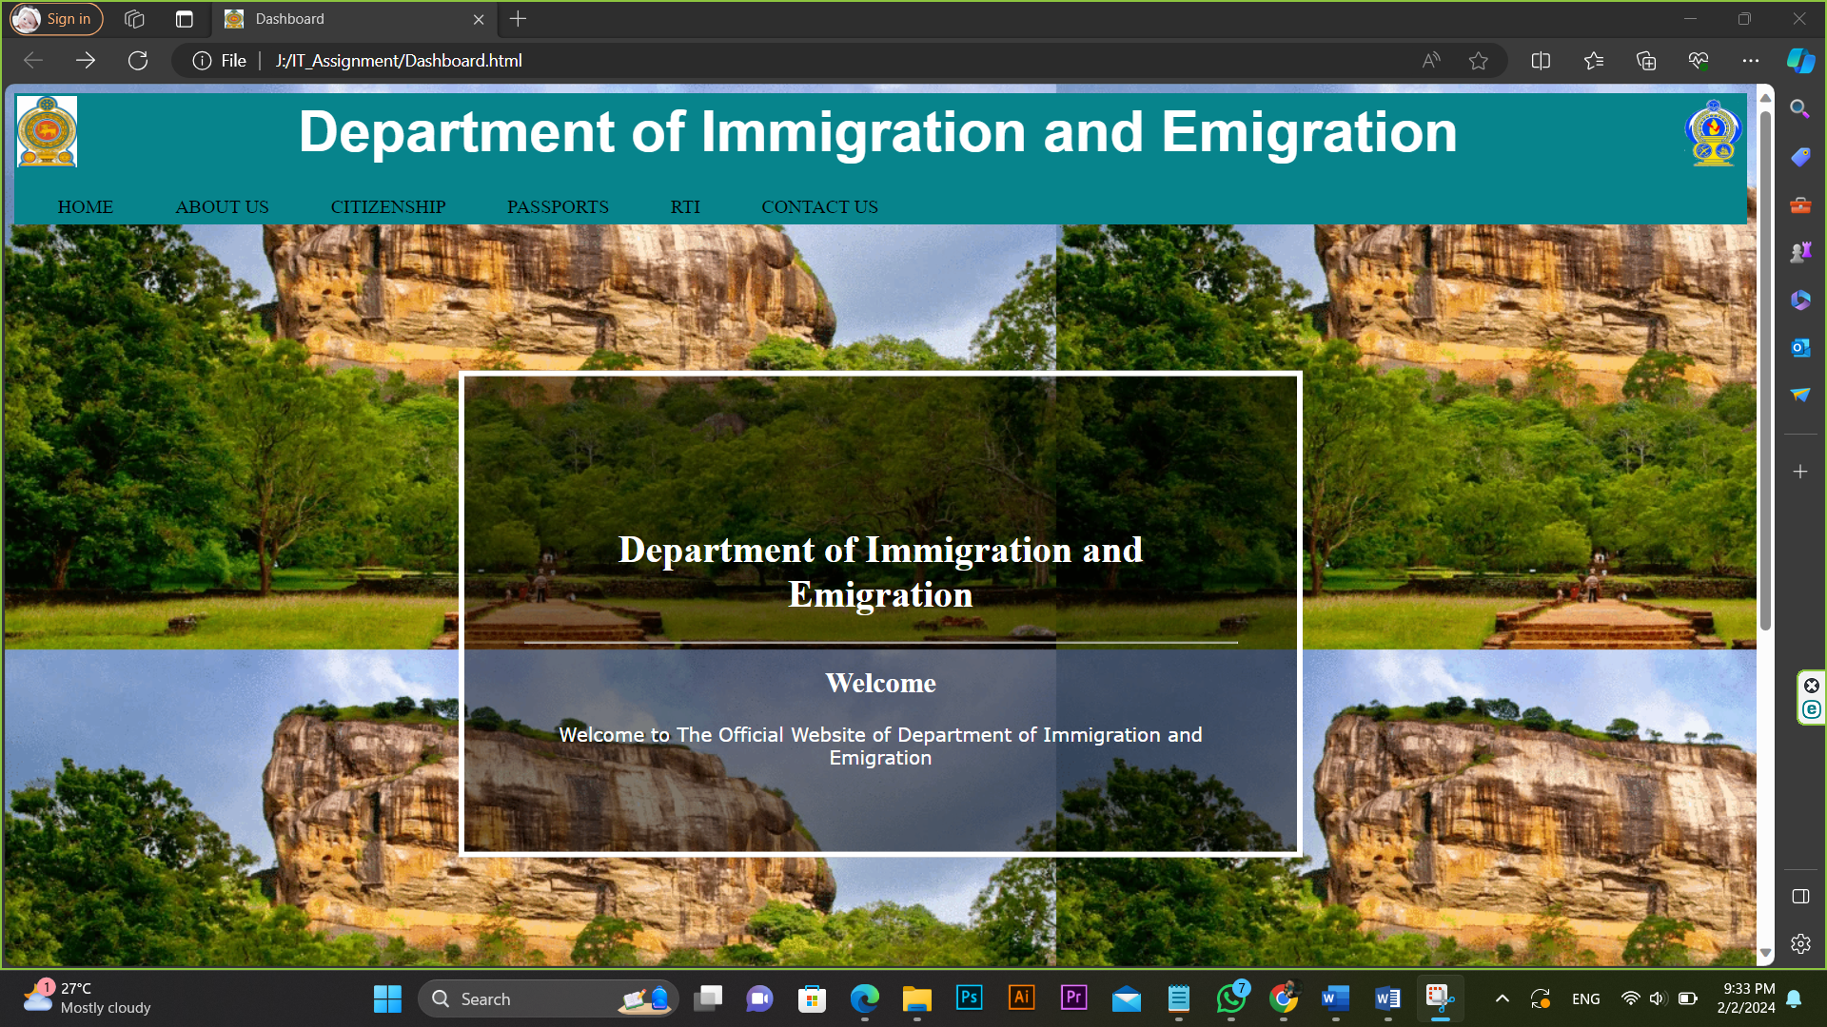

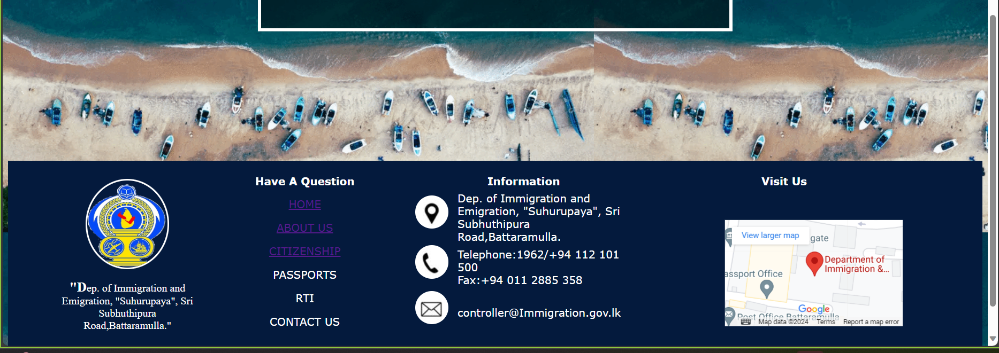

# 4. About us page

## Our vision and mission(vission_and_mission.html)

<html>

<head>

<title></title>

<link rel="icon" type="image/x-icon" href="OIP.jfif">

<link rel="stylesheet" type="text/css" href="cssdoc.css" />

</head>

<body>

<div class="header1">

<table width=100%>

<tr> <td><img src="OIP.jfif" width=50 height=60></td>

<td id="td1"><center><font size=10 color="white"><b>Department of Immigration and Emigration</b></font></center></td>

<td><img src="R.png" width=50 height=60 align="right"></td>

</tr>

</table>

</div>

<div class="header2">

<table cellpadding="10">

<tr> <td><div class="tab">

<a name="one">HOME</a>

<div class="sub-tabs">

<a href="Dashboard.html" class="sub-tab">Home</a>

</div>

</div></td>

<td><div class="tab">

<a name="two">ABOUT US</a>

<div class="sub-tabs">

<a href="vission_and_mission.html" class="sub-tab">Our vission & mission</a><br><br>

<a href="history.html" class="sub-tab">Department history</a>

</div>

</div></td>

<td><div class="tab">

<a name="three">CITIZENSHIP</a>

<div class="sub-tabs">

<a href="citizenship_genaral_information.html" class="sub-tab">General information</a><br><br>

<a href="citizenship_overseas_birth.html" class="sub-tab">Overseas birth registration</a>

</div>

</div></td>

<td><div class="tab">

PASSPORTS

<div class="sub-tabs">

<a href="Passport_Genaral_Info.html" class="sub-tab">General information</a>

</div>

</div></td>

<td><div class="tab">

RTI

<div class="sub-tabs">

<a href="RTI.html" class="sub-tab">RTI</a><br>

</div>

</div></td>

<td><div class="tab">

CONTACT US

<div class="sub-tabs">

<a href="contact_us.html" class="sub-tab">Contact details</a>

</div>

</div></td>

</tr>

</table>

</div>

<h1>Vision and Mission</h1>

<h2>Our Vision</h2>

<p>To be the best immigration service in the region</p>

<h2>Our Mission</h2>

<p>We regulate the entry and exit of persons, and provide citizenship services, while safeguarding the nation's security & social order, and promoting economic development.</p>

<h3>Powers, Duties and Functions Of The Immigration and Emigration Department</h3>

<p>As mentioned in the preamble of Immigrants and Emigrants act no 20 of 1948 it has been enacted to make provision;</P>

<ul>

<li>For controlling the entry into Sri Lanka of persons other than citizens of Sri Lanka,</li>

<li>For regulating the departure from Sri Lanka the citizens, and persons other than citizens of Sri Lanka,</li>

<li>For removing from Sri Lanka undesirable persons who are not citizens of Sri Lanka, and,</li>

<li>For other matters incidental to or connected with the matters aforesaid.</li>

</ul>

<p>Immigrants and Emigrants Act came into operation with effect from 01-11-1949.</p>

<p>Immigration and Emigration department is established to implement the provisions of the Act.</p>

<h3>Powers</h3>

<p>The controller and other officers appointed under the provisions of the section 4 of the act are empowered to exercise, perform, or discharge of the powers, duties, or functions, conferred, imposed,

or assigned by or under the Immigrants and emigrants act. Powers conferred by section 2 or section 31 or section 52 should be exercised by the minister him self. (See sections 4, 5, 6, & 7 of the act.

/ See part II of the Immigrants and Emigrants Act for the administrative arrangements. )</p>

<p>Entry into Sri Lanka of persons other than citizens of Sri Lanka is controlled according to the provisions of part III of the act. This part is related to the matters connected with approved ports of entry,

documents required at the entry, requirement of visa to entry into & stay in Sri Lanka, medical & other examinations upon arrival, inspection of persons & their belongings and detention & removal of certain persons from Sri Lanka.</p>

<p>Activities of persons other than citizens of Sri Lanka during their stay are supervised under the powers conferred by the part IV of the act.</p>

<p>Removal & deportation of persons other than citizens of Sri Lanka is carried out when necessary within the powers conferred by the parts V & VI of the act.</p>

<p>Departure of persons from Sri Lanka is controlled by the part VII of the act. This part contains the provisions relating to the approved ports of departure, requirement of valid passport and making regulations connected to there in.

The provisions of this part apply to the citizens of Sri Lanka as well as foreign nationals.</p>

<h3>Duties</h3>

<ul>

<li>Granting required entry endorsements in travel documents of persons other than citizens of Sri Lanka at approved entry points. (See sections 11 & 13 of the act )</li>

<li>Keeping and maintaining a register of persons who are non citizens of Sri Lanka at entry points. (See section 26 )</li>

<li>Stamping the travel documents of persons leaving Sri Lanka at departure points and maintaining records there in. (See regulation 56 )</li>

<li>Identification of persons entering and leaving Sri Lanka at approved ports. (See section 37 )</li>

</ul>

<h3>Functions</h3>

<ul>

<li>Exercising the powers vested by or under the Immigration & Emigration Act.</li>

<li>Performing the duties assigned by or under the Immigration & Emigration Act.

<li>Issuing visa to persons other than citizens of Sri Lanka to enter and stay in Sri Lanka, and border controlling. (See part III of the act )</li>

<li>Issuing travel documents to the citizens of Sri Lanka. (See part VII of the act.)</li>

<li>Maintaining detention places approved by the minister. (See section 48 )</li>

<li>Conducting investigations on violations of provisions made by or under the act.</li>

<li>Keeping and maintaining the information and records connected to the functions mentioned above.</li>

</ul>

<div class="footer1"><br>

<table align="center" style="width:90%">

<tr>

<td rowspan=2 style="text-align:center;width:15%;">

<img class="img1" src="R.png" width="120" height="130"><br><p class="p1" style="font-family:Angsana New; color:white;">

"Dep. of Immigration and Emigration, "Suhurupaya", Sri Subhuthipura Road,Battaramulla."</p></td>

<td style="text-align:center;width:23%;"><p style="font-weight:bold; color:white;">Have A Question</p></td>

<td style="width:20%;"><p style="font-weight:bold; color:white; text-align:center;">Information</p></td>

<td style="text-align:center;width:32%;"><p style="font-weight:bold; color:white;">Visit Us</p></td>

</tr>

<tr>

<td><center><a href="#one"><p>HOME</p></a>

<a href="#two"><p>ABOUT US</p></a>

<a href="#three"><p>CITIZENSHIP</p></a>

<a style="color:white;text-decoration:none;" href="Passport_Genaral_Info.html"><p>PASSPORTS</p></a>

<a style="color:white;text-decoration:none;" href="RTI.html"><p>RTI</p></a>

<a style="color:white;text-decoration:none;" href="contact_us.html"><p>CONTACT US</p></a>

</center></td>

<td> <table>

<tr>

<td>

<ul class="list1">

<li class="icon1"></li>

</ul></td>

<td>

<p style="color:white;">

Dep. of Immigration and Emigration, "Suhurupaya", Sri Subhuthipura Road,Battaramulla.

</p></td>

</tr>

<tr>

<td>

<ul class="list1">

<li class="icon2"></li>

</ul></td>

<td>

<p style="color:white;">Telephone:1962/+94 112 101 500<br>

Fax:+94 011 2885 358</p>

</tr>

<tr>

<td>

<ul class="list1">

<li class="icon3"></li>

</ul></td>

<td>

<p style="color:white;">controller@Immigration.gov.lk</p>

</tr>

</table>

</td>

<td>

<div class="gmap">

<iframe src="https://www.google.com/maps/embed?pb=!1m18!1m12!1m3!1d495.1131308234952!2d79.9220707648389!3d6.901958164654896!2m3!1f0!2f0!3f0!3m2!1i1024!2i768!4f13.1!3m3!1m2!1s0x3ae2590ae37765f1%3A0x1dbb558b4ad5ebad!2sDepartment%20of%20Immigration%20%26%20Emigration!5e0!3m2!1sen!2slk!4v1706818538948!5m2!1sen!2slk" width="100%" height="50%" style="border:0;" allowfullscreen="" loading="lazy" referrerpolicy="no-referrer-when-downgrade">

</iframe>

</div>

</td>

</tr>

</table>

</div>

<div style="background-color:black; width:100%; height: 30px;">

<div class="footer2">

<p style="color: white;text-align:center;">Copyright © 2022, Dep. of Immigration & Emigration Sri Lanka All rights reserved.</p>

</div>

</div>

</body>

</html>

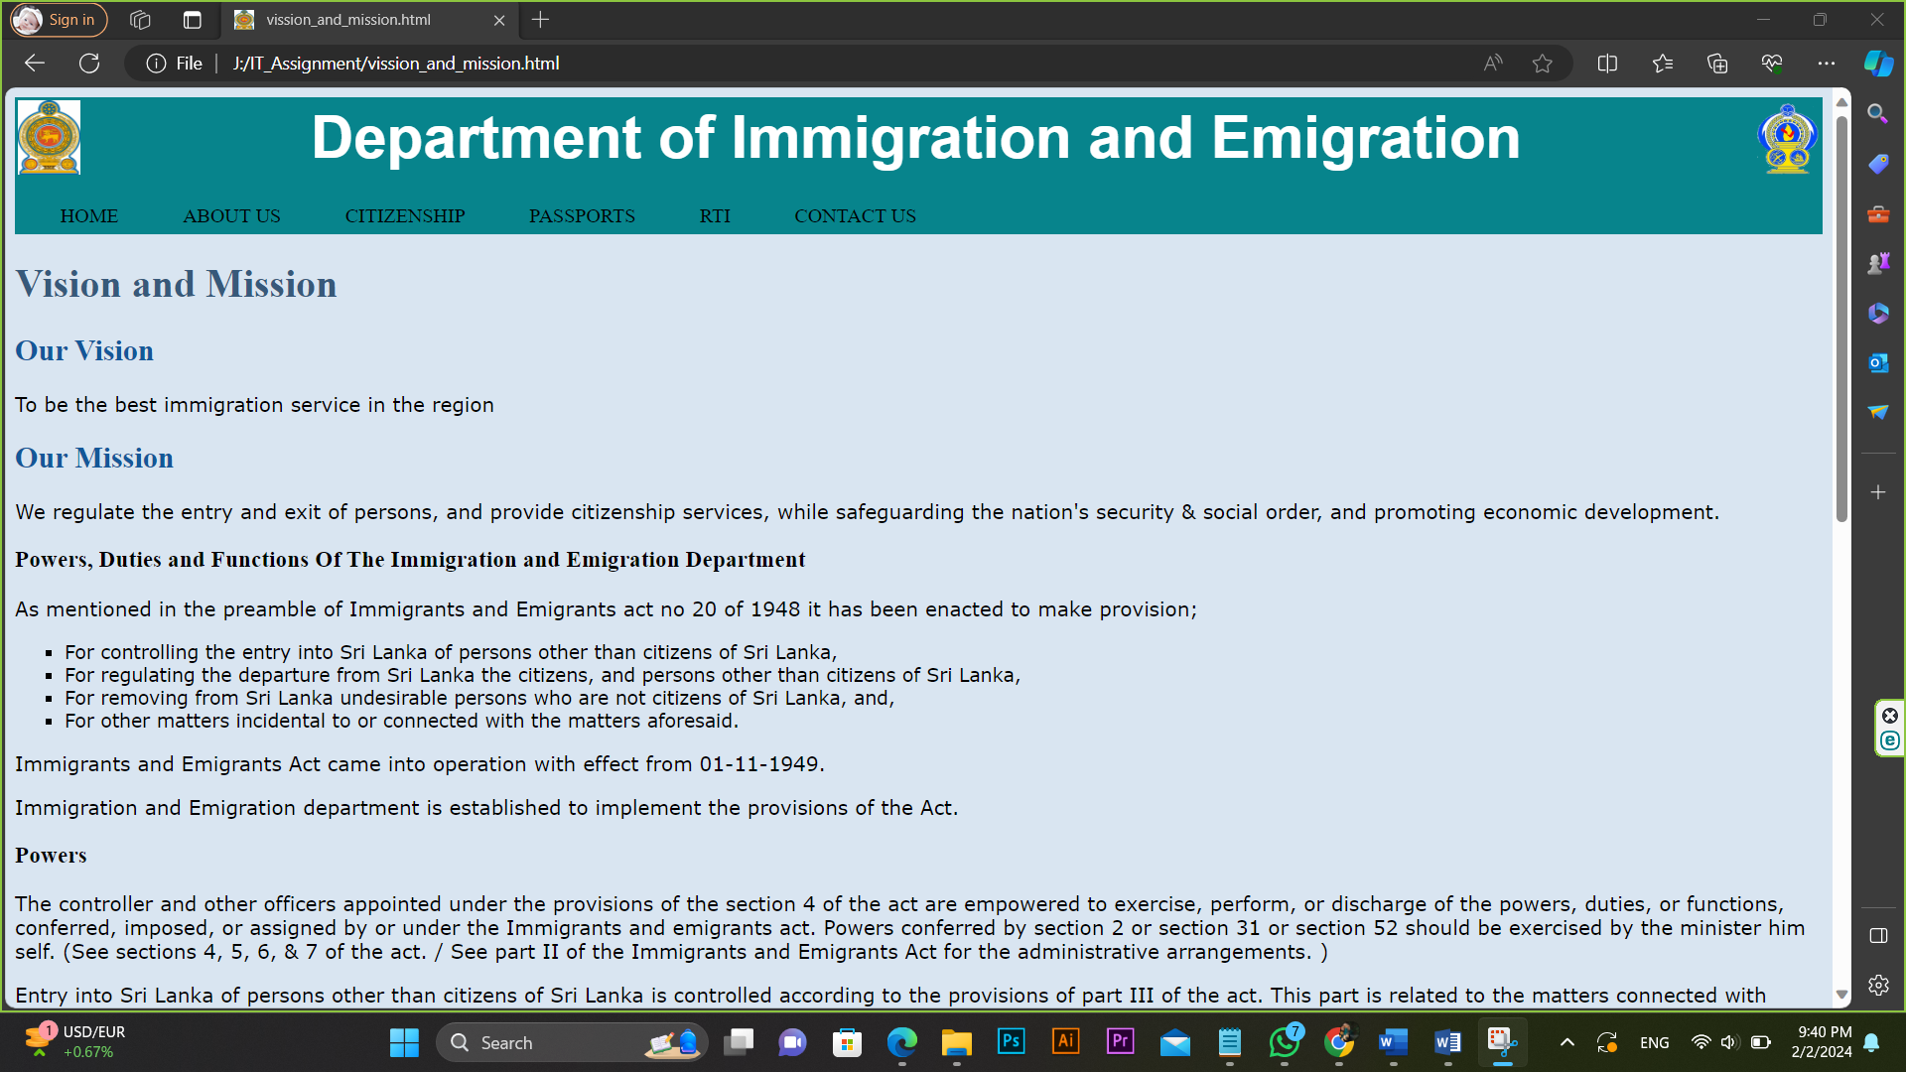

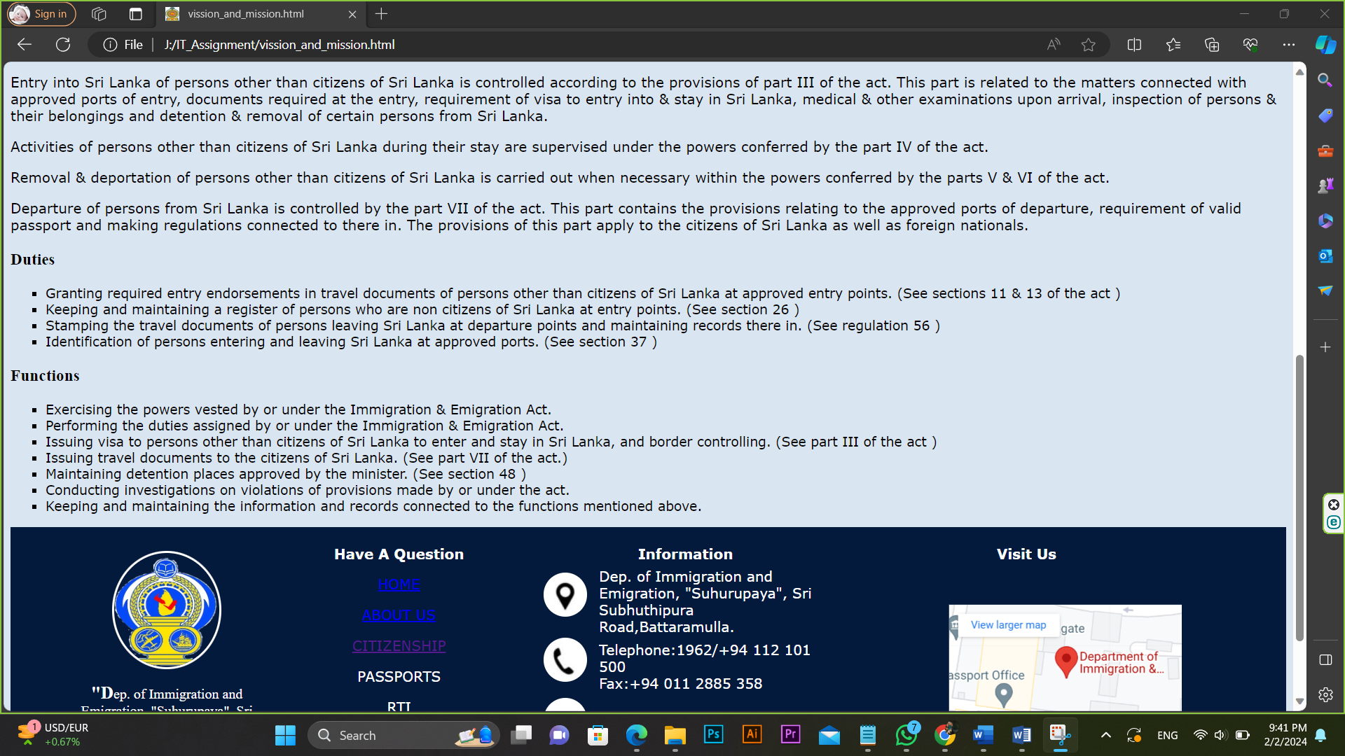

## Department history(history.html)

<html>

<head>

<title></title>

<link rel="icon" type="image/x-icon" href="OIP.jfif">

<link rel="stylesheet" type="text/css" href="cssdoc.css" />

</head>

<body>

<div class="header1">

<table width=100%>

<tr> <td><img src="OIP.jfif" width=50 height=60></td>

<td id="td1"><center><font size=10 color="white"><b>Department of Immigration and Emigration</b></font></center></td>

<td><img src="R.png" width=50 height=60 align="right"></td>

</tr>

</table>

</div>

<div class="header2">

<table cellpadding="10">

<tr> <td><div class="tab">

<a name="one">HOME</a>

<div class="sub-tabs">

<a href="Dashboard.html" class="sub-tab">Home</a>

</div>

</div></td>

<td><div class="tab">

<a name="two">ABOUT US</a>

<div class="sub-tabs">

<a href="vission_and_mission.html" class="sub-tab">Our vission & mission</a><br><br>

<a href="history.html" class="sub-tab">Department history</a>

</div>

</div></td>

<td><div class="tab">

<a name="three">CITIZENSHIP</a>

<div class="sub-tabs">

<a href="citizenship_genaral_information.html" class="sub-tab">General information</a><br><br>

<a href="citizenship_overseas_birth.html" class="sub-tab">Overseas birth registration</a>

</div>

</div></td>

<td><div class="tab">

PASSPORTS

<div class="sub-tabs">

<a href="Passport_Genaral_Info.html" class="sub-tab">General information</a>

</div>

</div></td>

<td><div class="tab">

RTI

<div class="sub-tabs">

<a href="RTI.html" class="sub-tab">RTI</a><br>

</div>

</div></td>

<td><div class="tab">

CONTACT US

<div class="sub-tabs">

<a href="contact_us.html" class="sub-tab">Contact details</a>

</div>

</div></td>

</tr>

</table>

</div>

<h1>History of Immigration & Emigration and Citizenship of Sri Lanka</h1>

<h2>Immigration & Emigration before Independence</h2>

<p>To be the best immigration service in the region</p>

<p>During the period when Ceylon was a British colony, entry into and exit from Sri Lanka

(then Ceylon) was controlled by the following ordinances:</p>

<ul>

<li>Emigration of Indians from Ceylon Ordinance no 3 of 1847</li>

<li>Foreign Recruiting Ordinance no 01 of 1874</li>

<li>Ceylon emigrants Ordinance no 04 of 1882</li>

<li>Destitute Immigrants Ordinance no 12 of 1907</li>

<li>Emigration Ordinance no 22 of 1917</li>

<li>Passport Ordinance no 20 of 1923</li>

<li>Aliens Registration Ordinance no 30 of 1935</li>

<li>Indian Criminal Tribes Immigration Ordinance no 19 of 1939</li>

</ul>

<p><strong>Emigration of Indians from Ceylon Ordinance 1847 </strong>has been enacted to, prohibit natives of India from, entering into contracts in Ceylon, for labor to be performed

in any British or foreign colony beyond the limits of India or Ceylon, and from emigrating, from Ceylon to any such colony, for the purpose of employment as laborers.<strong>&nbsp;</strong></p>

<p><strong>Foreign Recruiting Ordinance 1874 </strong>was enacted to, control recruiting in Ceylon, for the service of foreign states. BY this law, governor was authorized to, prohibit recruiting

persons, for service of foreign states beyond the limits of Ceylon; or permit to do so subject to conditions.&nbsp;</p>

<p><strong>Ceylon Emigrants Ordinance 1882</strong> was enacted to; regulate the emigration of Ceylonese laborers from, Ceylon under contract of service. By this law, governor was empowered to,

declare places where Ceylonese laborers were allowed to, emigrate. It was subject to the condition that such contracts should be signed before a magistrate.</p>

<p><strong>Destitute Immigrants Ordinance1907</strong> was enacted to, restrict immigration into Ceylon of destitute, and vicious persons, and of stowaways. The main objective of this law was,

preventing the entry of persons, who would be a liability to the Treasury. By this law a person other than a native of Ceylon or native of British India, &nbsp; who was unable, by reason of physical

or mental infirmity, to maintain himself by his own labor, or is destitute, was not permitted to land. Entry of such a person was permitted only on a bond entered into by a local to the effect that

he would repay to the financial secretary any cost and charges, may be incurred in respect of such destitute immigrant. The entry into Ceylon of any prostitute or any person living on the prostitution,

too was prohibited by this law.</p>

<p><strong>Emigration ordinance 1917</strong> was enacted to regulate the emigration of persons from Ceylon for the purpose of employment in certain capacities outside the island. In this law emigrant

was defined as a native person living in Ceylon and Indian emigrant was defined as a native person of India, other than a person who has obtained a pass under any law in force in British India regulating

the issue of passes to Indian emigrants.Provision was made in this law to, both emigrants and Indian emigrants to obtain the consent of chief secretary in writing for embarkation. Only the persons who were

over seventeen years of age were granted with consent. They were required to obtain a pass from the collector of customs and enter into a bond with the crown. Further they had to keep a deposit of three

hundred rupees with the collector of customs. The persons who were emigrating for employment purposes had to sign a service contract with their employer, and it should have been attested by the controller

of customs. In addition to that, there were several provisions, regards to the responsibilities of masters of ships, powers of police officers to search and arrest, and medical examinations at the port,

and penalties.</p>

<p><strong>Passport Ordinance 1923</strong> was enacted to make provision to take power to require passports of persons entering or departing from Ceylon. The governor was granted with powers to make

regulations requiring that persons entering or departing from Ceylon should be on possession of passports, and matters related to that purpose. Further, he was empowered, to exempt of any person or

class of persons from any provision of such regulations. The regulations made under this law were effected up to October 28 of 1949, until the &nbsp;new immigration and emigration regulations make

under the immigrants and emigrants act no 20 of 1948, came into effect.</p>

<p>Aliens’ Registration Ordinance 1935 was enacted to make provision for the registration of aliens (a person other than a British subject or British protected person) in Ceylon.

The registrar of aliens was appointed by the governor under the provision of this law. By this law, any alien who was intending to remain in the island for a period of one month or longer was

ordered to furnish a return to the registrar. Further there was provision regards to the, restrictions of movements within the island, deportation of aliens, and verification of returns.

So it was something similar to the visa requirements of present day.</p>

<p><strong>Indian criminal tribes immigration ordinance no.19 of 1939</strong></p>

<p>This ordinance was enacted by state council, and assented by his majesty the king on 1939.05.23 to restrict the immigration of Indian criminal tribes in to Ceylon.

Those days there were some tribes organized as gangs and engaged with criminal activities in India. They were commonly known as Thugs and were declared as criminal tribes

by the laws in force in India at that time. By this ordinance the governor of Ceylon was empowered to declare such tribes as criminal tribes in Ceylon by notification.

The entry in to Ceylon of such tribes was prohibited without a permit. Provisions were made relating to the removal, arrest, penalties for abetting, and taking fingerprints

of such persons by this ordinance. The chief secretary was empowered to make regulations pertaining to the restrictions.</p>

<p>This ordinance was in force until 1948 and it was repealed by the immigrants and emigrants act no 20 of 1948.</p>

<p><strong>Immigration &amp; emigration After independence</strong></p>

<p><strong>Immigrants and Emigrants Act No. 20 of 1948</strong></p>

<p>After gaining Independence from British, the then Parliament promulgated the Immigrants and Emigrants Act No. 20 of 1948. It was assented on October 6, 1948 and came into effect on 1 November 1949.

In this Act, provisions was made, to control of entry and remain of non-Ceylonese,&nbsp;&nbsp; to regulate the departure from Ceylon the citizens, and persons&nbsp; other than&nbsp;&nbsp;

the citizens of Ceylon ,&nbsp; to&nbsp;remove or deport&nbsp; non-Ceylonese who have committed offences under the act or who are undesirables, to supervise the activities of non Ceylonese during

their stay in Ceylon, and to organize the administrative set-up for the implementation of the above objectives and matters incidental thereto and connected therein. Regulations made under the

Act were published in the <strong>Gazette no 10039 issued on 28 October 1949</strong></p>

<p>Emigration of Indians from Ceylon ordinance, foreign recruiting ordinance, Indian criminal tribes’ immigration ordinance, Destitute Immigrants Ordinance,

Emigration ordinance, Passport Ordinance, Aliens registration ordinance, &amp; Ceylon emigrants’ ordinance, were repealed by this law.</p>

<p>Immigrants and Emigrants Act No. 20 of 1948 has been amended at several occasions by the <strong>Amendment Acts no 16 of 1955, no 68 of 1961, no 16 of 1993, no 42 of 1998, and no 31 of

2006 and no. 07 of 2015 </strong>respectively.</p>

<p>Significant changes made by these amendments were as follows.</p>

<p>Provisions on permanent &amp; temporary residents permits of main act were repealed and resident visa provisions were included instead of them by the <strong>Amendment Act no 16 of 1955.</strong></p>

<p>The governor general was empowered to authorize any member of the forces to exercise and discharge powers and duties under the immigrants and emigrants act, by the <strong>Amendment Act no 68 of 1961.

</strong> The aim of this amendment was to stop illicit immigrant entering into the country.</p>

<p>The Authority prescribed to issue or renew passports were empowered to take finger printing for the inclusion in the passport, from a person applying for a passport or the renewal of a passport,

by the Amendment Act no 07 of 2015</p>

<p>In 1972 Ceylon became a republic. The name of the country was changed as the democratic socialist republic of Sri Lanka. After that, immigrants and emigrants act has been amended thrice, in 1993,

1998, and 2006 respectively. All those occasions it was regard to restrict illicit emigrants from Sri Lanka as well as illicit immigrants remain in Sri Lanka.</p>

<p>In addition to that following related laws were enacted for specific purposes mentioned below.</p>

<p><strong>Temporary Residence Tax Act no 15 of 1971</strong> was enacted to; make provision for the levy and recovery of a tax computed with reference to the stay in Sri Lanka of certain persons

who are not citizens of Sri Lanka.</p>

<p><strong>Passport (regulations) and Exit Permit Act no 53 of 1971</strong> was enacted to provide for regulation and control of the issue and renewal of passports; for the issue of exit permits

to citizen of Sri Lanka; and to impose an obligation on citizens of Sri Lanka employed abroad to remit a part of their earnings in foreign exchange to Sri Lanka.</p>

<p><strong>Resident Guest (tax exemption) Act no 06 of 1979</strong> was enacted to exempt certain categories of resident visa holders from certain taxes. Resident guests were granted with above

exemption by this law.</p>

<p><strong>Department of Immigration and Emigration</strong></p>

<p>With the enactment of the immigration &amp; emigration act, the necessity was aroused to establish a new department to implement the provisions of it. This new Department was established in

October 1949 and started in Colombo Fort. The Assistant Secretary of the Ministry of Defense was transferred together with his staff to the newly formed Department. Police Department,

which attended to the field duties, was requested to hand over of those functions to the newly formed Department.&nbsp; The implementation of the new law was postponed until 01st November 1949

till relief arrangements were made effected to those affected by the new Act. The practice of issuing British Passports to Citizens of Sri Lanka was stopped with effect from 01.11.1949.

The New Ceylon Passport came into use from then, and the holder had to be a Citizen of Ceylon.</p>

<div class="footer1"><br>

<table align="center" style="width:90%">

<tr>

<td rowspan=2 style="text-align:center;width:15%;">

<img class="img1" src="R.png" width="120" height="130"><br><p class="p1" style="font-family:Angsana New; color:white;">

"Dep. of Immigration and Emigration, "Suhurupaya", Sri Subhuthipura Road,Battaramulla."</p></td>

<td style="text-align:center;width:23%;"><p style="font-weight:bold; color:white;">Have A Question</p></td>

<td style="width:20%;"><p style="font-weight:bold; color:white; text-align:center;">Information</p></td>

<td style="text-align:center;width:32%;"><p style="font-weight:bold; color:white;">Visit Us</p></td>

</tr>

<tr>

<td><center><a href="#one"><p>HOME</p></a>

<a href="#two"><p>ABOUT US</p></a>

<a href="#three"><p>CITIZENSHIP</p></a>

<a style="color:white;text-decoration:none;" href="Passport_Genaral_Info.html"><p>PASSPORTS</p></a>

<a style="color:white;text-decoration:none;" href="RTI.html"><p>RTI</p></a>

<a style="color:white;text-decoration:none;" href="contact_us.html"><p>CONTACT US</p></a>

</center></td>

<td> <table>

<tr>

<td>

<ul class="list1">

<li class="icon1"></li>

</ul></td>

<td>

<p style="color:white;">

Dep. of Immigration and Emigration, "Suhurupaya", Sri Subhuthipura Road,Battaramulla.

</p></td>

</tr>

<tr>

<td>

<ul class="list1">

<li class="icon2"></li>

</ul></td>

<td>

<p style="color:white;">Telephone:1962/+94 112 101 500<br>

Fax:+94 011 2885 358</p>

</tr>

<tr>

<td>

<ul class="list1">

<li class="icon3"></li>

</ul></td>

<td>

<p style="color:white;">controller@Immigration.gov.lk</p>

</tr>

</table>

</td>

<td>

<div class="gmap">

<iframe src="https://www.google.com/maps/embed?pb=!1m18!1m12!1m3!1d495.1131308234952!2d79.9220707648389!3d6.901958164654896!2m3!1f0!2f0!3f0!3m2!1i1024!2i768!4f13.1!3m3!1m2!1s0x3ae2590ae37765f1%3A0x1dbb558b4ad5ebad!2sDepartment%20of%20Immigration%20%26%20Emigration!5e0!3m2!1sen!2slk!4v1706818538948!5m2!1sen!2slk" width="100%" height="50%" style="border:0;" allowfullscreen="" loading="lazy" referrerpolicy="no-referrer-when-downgrade">

</iframe>

</div>

</td>

</tr>

</table>

</div>

<div style="background-color:black; width:100%; height: 30px;">

<div class="footer2">

<p style="color: white;text-align:center;">Copyright © 2022, Dep. of Immigration & Emigration Sri Lanka All rights reserved.</p>

</div>

</div>

</body>

</html>

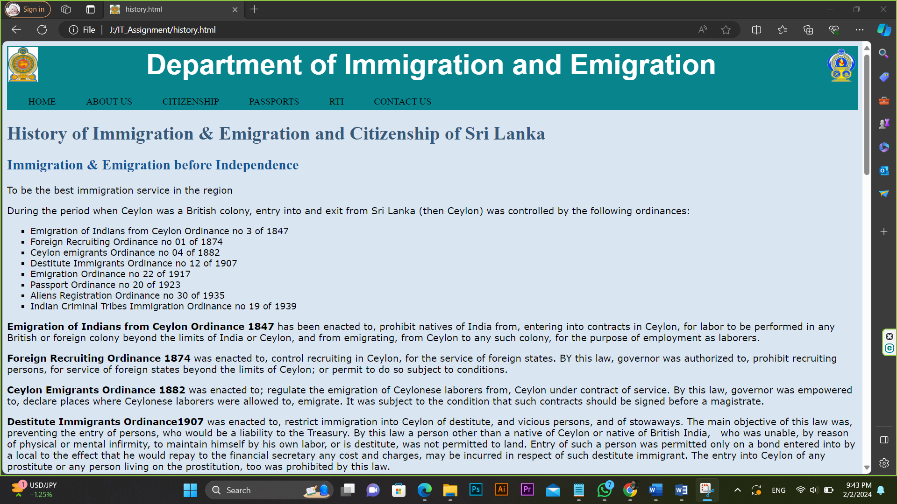

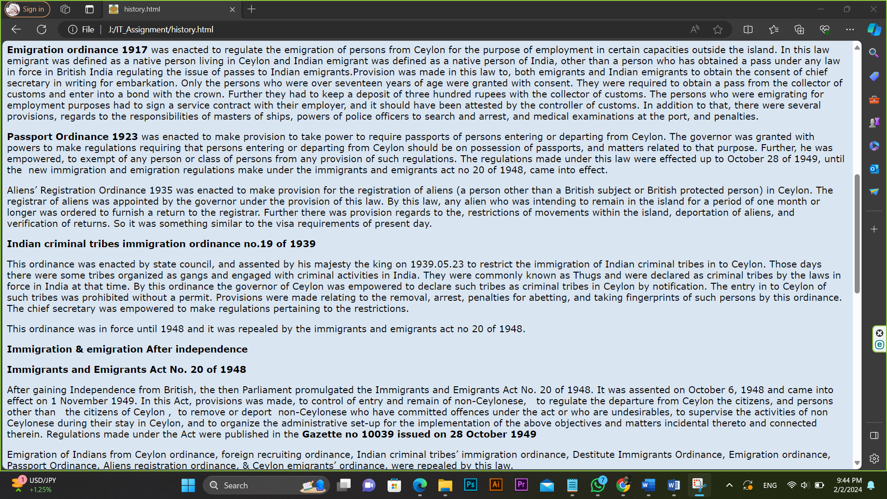

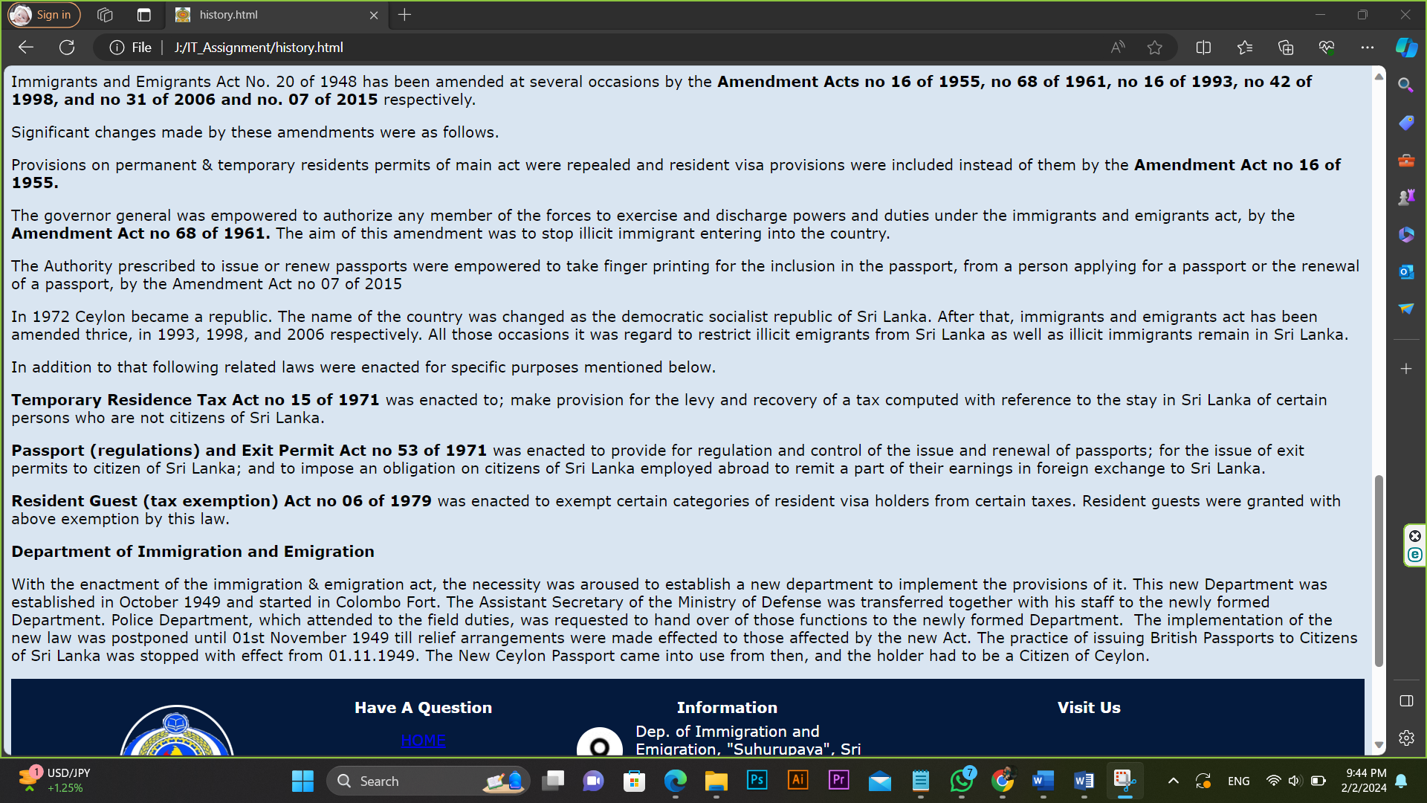

# 5.Citizenship page

## General information(citizenship_genaral_information.html)

<html>

<head>

<title></title>

<link rel="icon" type="image/x-icon" href="OIP.jfif">

<link rel="stylesheet" type="text/css" href="cssdoc.css" />

</head>

<body>

<div class="header1">

<table width=100%>

<tr> <td><img src="OIP.jfif" width=50 height=60></td>

<td id="td1"><center><font size=10 color="white"><b>Department of Immigration and Emigration</b></font></center></td>

<td><img src="R.png" width=50 height=60 align="right"></td>

</tr>

</table>

</div>

<div class="header2">

<table cellpadding="10">

<tr> <td><div class="tab">

<a name="one">HOME</a>

<div class="sub-tabs">

<a href="Dashboard.html" class="sub-tab">Home</a>

</div>

</div></td>

<td><div class="tab">

<a name="two">ABOUT US</a>

<div class="sub-tabs">

<a href="vission_and_mission.html" class="sub-tab">Our vission & mission</a><br><br>

<a href="history.html" class="sub-tab">Department history</a>

</div>

</div></td>

<td><div class="tab">

<a name="three">CITIZENSHIP</a>

<div class="sub-tabs">

<a href="citizenship_genaral_information.html" class="sub-tab">General information</a><br><br>

<a href="citizenship_overseas_birth.html" class="sub-tab">Overseas birth registration</a>

</div>

</div></td>

<td><div class="tab">

PASSPORTS

<div class="sub-tabs">

<a href="Passport_Genaral_Info.html" class="sub-tab">General information</a>

</div>

</div></td>

<td><div class="tab">

RTI

<div class="sub-tabs">

<a href="RTI.html" class="sub-tab">RTI</a><br>

</div>

</div></td>

<td><div class="tab">

CONTACT US

<div class="sub-tabs">

<a href="contact_us.html" class="sub-tab">Contact details</a>

</div>

</div></td>

</tr>

</table>

</div>

<h1>General Information on Citizenship</h1>

<p><strong>General Provisions for Sri Lankan Citizenship</strong></p>

<p>Citizenship Division offers you the services of registering your overseas born child/ children, renouncing Sri Lankan Citizenship, or registering person as a Sri Lankan Dual Citizen.</p>

<p>Applications are accepted by Citizenship Division (Level 04 - Wing D) at the Department of Immigration and Emigration Head Office.</p>

<p>Working Hours:&nbsp; Monday to Friday except Public holidays<br>

Applications are accepted from 9.00a.m to 2.30 p.m.</p>

<p>&nbsp;</p>

<p><b>Special Provisions for Sri Lankan Citizenship</b></p>

<ol>

<li>Issuing certificates confirming the Sri Lankan citizenship to persons of Indian Origin, under the provisions of Grant of citizenship to stateless persons (special provisions ) Act, no: 39 of 1988 &amp; Grant of citizenship to persons of Indian origin Act, no: 35 of 2003; and<br>

&nbsp;</li>

<li>Issuing acknowledgements to persons of Indian origin who have made special declarations under section 2 of Grant of citizenship to persons of Indian origin Act no; 35 of 2003.<br>

&nbsp;</li>

<li>Authenticating the Sri Lankan citizenship certificates issued under the provisions of,

<ol>

<li>Indian &amp; Pakistan residents citizenship Act, no: 03 of 1949</li>

<li>Indo - Ceylon agreement implementation (special provisions) Act, no:14 of 1967</li>

<li>Grant of citizenship to stateless persons (special provisions ) Act, no:39 of 1988</li>

<li>Grant of citizenship to Persons of Indian origin Act, no:35 of 2003 and</li>

<li>Grant of citizenship to persons of&nbsp; Chinese origin (special provisions ) act, no: 38 of 2008</li>

</ol>

</li>

</ol>

<p>Applications are accepted at Indo - Lanka Citizenship Division (Level 06 – Wing D) at the Head Office of Department of Immigration and Emigration.</p>

<p>Working Hours :&nbsp;&nbsp; &nbsp;Monday to Friday except Public Holidays.<br>

Applications for Registration /Citizenship confirmation certificates are accepted from 09.00 a.m. to 03.00 p.m.at the Indo - Lanka Citizenship Division.</p>

<p>&nbsp;</p>

<div class="footer1"><br>

<table align="center" style="width:90%">

<tr>

<td rowspan=2 style="text-align:center;width:15%;">

<img class="img1" src="R.png" width="120" height="130"><br><p class="p1" style="font-family:Angsana New; color:white;">

"Dep. of Immigration and Emigration, "Suhurupaya", Sri Subhuthipura Road,Battaramulla."</p></td>

<td style="text-align:center;width:23%;"><p style="font-weight:bold; color:white;">Have A Question</p></td>

<td style="width:20%;"><p style="font-weight:bold; color:white; text-align:center;">Information</p></td>

<td style="text-align:center;width:32%;"><p style="font-weight:bold; color:white;">Visit Us</p></td>

</tr>

<tr>

<td><center><a href="#one"><p>HOME</p></a>

<a href="#two"><p>ABOUT US</p></a>

<a href="#three"><p>CITIZENSHIP</p></a>

<a style="color:white;text-decoration:none;" href="Passport_Genaral_Info.html"><p>PASSPORTS</p></a>

<a style="color:white;text-decoration:none;" href="RTI.html"><p>RTI</p></a>

<a style="color:white;text-decoration:none;" href="contact_us.html"><p>CONTACT US</p></a>

</center></td>

<td> <table>

<tr>

<td>

<ul class="list1">

<li class="icon1"></li>

</ul></td>

<td>

<p style="color:white;">

Dep. of Immigration and Emigration, "Suhurupaya", Sri Subhuthipura Road,Battaramulla.

</p></td>

</tr>

<tr>

<td>

<ul class="list1">

<li class="icon2"></li>

</ul></td>

<td>

<p style="color:white;">Telephone:1962/+94 112 101 500<br>

Fax:+94 011 2885 358</p>

</tr>

<tr>

<td>

<ul class="list1">

<li class="icon3"></li>

</ul></td>

<td>

<p style="color:white;">controller@Immigration.gov.lk</p>

</tr>

</table>

</td>

<td>

<div class="gmap">

<iframe src="https://www.google.com/maps/embed?pb=!1m18!1m12!1m3!1d495.1131308234952!2d79.9220707648389!3d6.901958164654896!2m3!1f0!2f0!3f0!3m2!1i1024!2i768!4f13.1!3m3!1m2!1s0x3ae2590ae37765f1%3A0x1dbb558b4ad5ebad!2sDepartment%20of%20Immigration%20%26%20Emigration!5e0!3m2!1sen!2slk!4v1706818538948!5m2!1sen!2slk" width="100%" height="50%" style="border:0;" allowfullscreen="" loading="lazy" referrerpolicy="no-referrer-when-downgrade">

</iframe>

</div>

</td>

</tr>

</table>

</div>

<div style="background-color:black; width:100%; height: 30px;">

<div class="footer2">

<p style="color: white;text-align:center;">Copyright © 2022, Dep. of Immigration & Emigration Sri Lanka All rights reserved.</p>

</div>

</div>

</body>

</html>

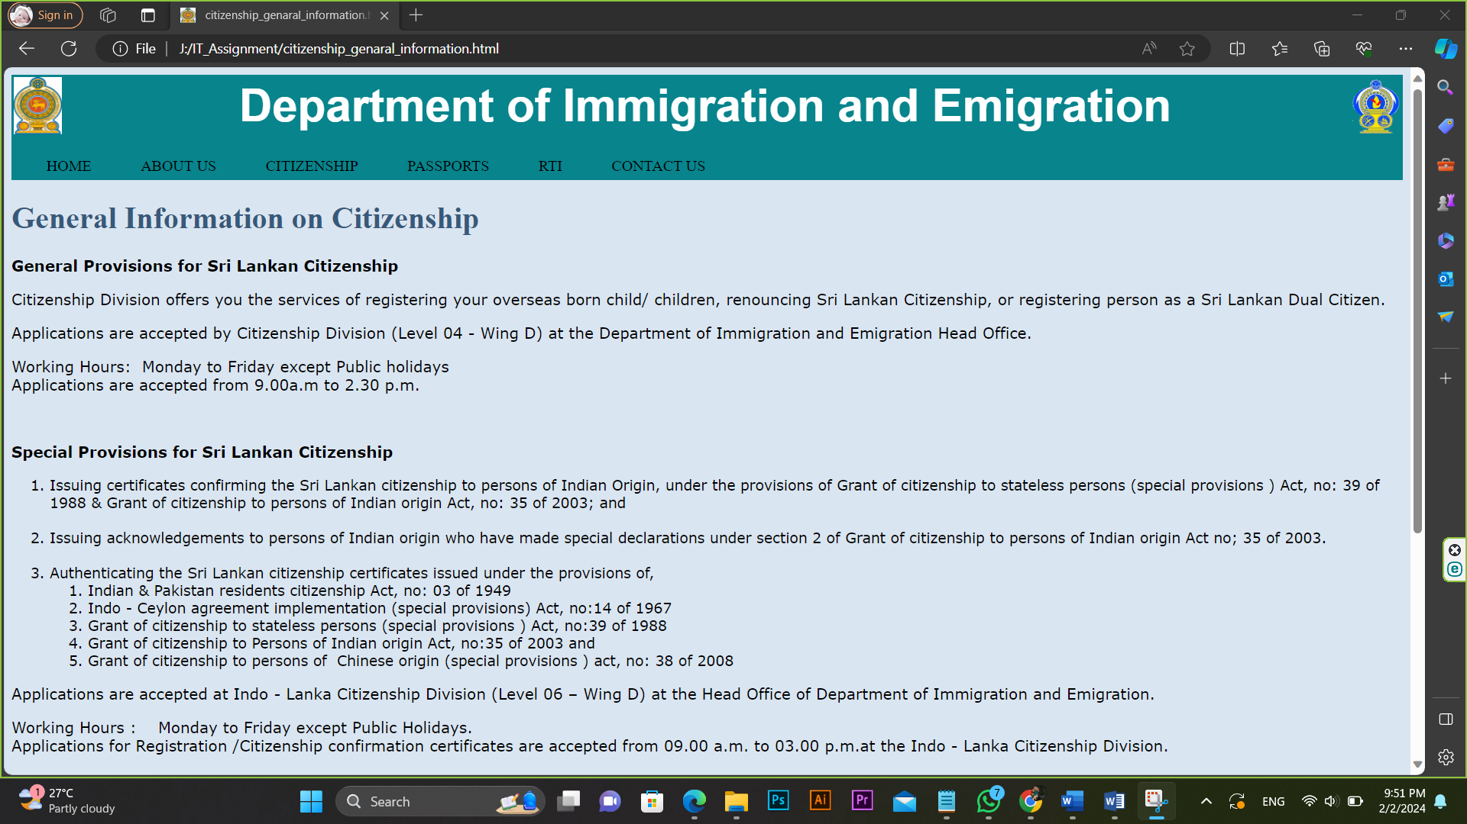

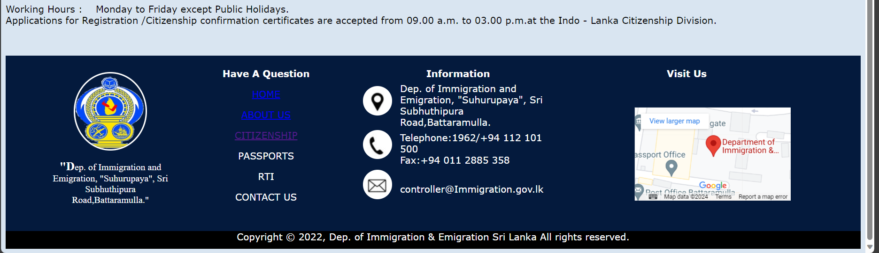

## Overseas birth registration(citizenship_overseas_birth.html)

<html>

<head>

<title></title>

<link rel="icon" type="image/x-icon" href="OIP.jfif">

<link rel="stylesheet" type="text/css" href="cssdoc.css" />

<style> input:focus {background-color:#20a6e8;}

textarea:focus {background-color:#20a6e8;}

</style>

</head>

<body>

<div class="header1">

<table width=100%>

<tr> <td><img src="OIP.jfif" width=50 height=60></td>

<td id="td1"><center><font size=10 color="white"><b>Department of Immigration and Emigration</b></font></center></td>

<td><img src="R.png" width=50 height=60 align="right"></td>

</tr>

</table>

</div>

<div class="header2">

<table cellpadding="10">

<tr> <td><div class="tab">

<a name="one">HOME</a>

<div class="sub-tabs">

<a href="Dashboard.html" class="sub-tab">Home</a>

</div>

</div></td>

<td><div class="tab">

<a name="two">ABOUT US</a>

<div class="sub-tabs">

<a href="vission_and_mission.html" class="sub-tab">Our vission & mission</a><br><br>

<a href="history.html" class="sub-tab">Department history</a>

</div>

</div></td>

<td><div class="tab">

<a name="three">CITIZENSHIP</a>

<div class="sub-tabs">

<a href="citizenship_genaral_information.html" class="sub-tab">General information</a><br><br>

<a href="citizenship_overseas_birth.html" class="sub-tab">Overseas birth registration</a>

</div>

</div></td>

<td><div class="tab">

PASSPORTS

<div class="sub-tabs">

<a href="Passport_Genaral_Info.html" class="sub-tab">General information</a>

</div>

</div></td>

<td><div class="tab">

RTI

<div class="sub-tabs">

<a href="RTI.html" class="sub-tab">RTI</a><br>

</div>

</div></td>

<td><div class="tab">

CONTACT US

<div class="sub-tabs">

<a href="contact_us.html" class="sub-tab">Contact details</a>

</div>

</div></td>

</tr>

</table>

</div>

<h1>Overseas Birth Registration</h1>

<p><strong>To whom is this applicable ?</strong></p>

<p>Children born outside Sri Lanka to Sri Lankan parents (At least one of the parents should be a Sri Lankan) needs to be registered at this Department within one year of birth for the confirmation of the child’s citizenship. A certificate for the Registration of Birth is issued to the applicant.</p>

<p><strong>What will happen if I fail to register the birth of my child within one year ?</strong></p>

<p>An extra fee will be imposed in the event of failure to register the birth of a child within a period of one year from the date of birth.</p>

<p><strong>What are the documents required to be handed over </strong><b>along </b><strong>with the completed application form ?</strong></p>

<ol>

<li>Birth Certificate of the child issued by the country where the birth took place. (If the original Birth Certificate is not in English, an English translation should be attached.)</li>

<li>Consular Birth Certificate issued by the Registrar&nbsp;General's Department of Sri Lanka.</li>

<li>Original Birth Certificates of parents</li>

<li>If the applicant (father or mother) is a Sri Lankan citizen by registration, the relevant certificate</li>

<li>Original Marriage Certificate of parents</li>

<li>Original Travel Documents and Visas held by parents to prove residence abroad at the time of the child's birth</li>

<li>Dual Citizenship certificates, if the parents are dual citizens.</li>

</ol>

<p><strong>Where can I obtain an Application Form ?</strong></p>

<ol>

<li>Citizenship Division Head Office of the Department of Immigration and Emigration, "Suhurupaya", Battaramulla.</li>

<li>Sri Lankan Mission in the country of residence.</li>

<li>Follow the application below. </li>

</ol>

<center><form action="#" method="post">

<table> <tr> <td colspan=2><h3>Child Information:</h3></td></tr>

<tr> <td><label for="full_name">Full Name of Applicant:</label></td>

<td><input type="text" id="full_name" name="full_name" required></td></tr>

<tr> <td><label for="postal_address">Postal Address in the country of domicile:</label></td>

<td><textarea id="postal_address" name="postal_address" rows="4" cols="20" required></textarea></td></tr>

<tr> <td><label for="email">Email Address:</label></td>

<td><input type="email" id="email" name="email" required></td></tr>

<tr> <td><label for="telephone_local">Telephone (Local):</label></td>

<td><input type="tel" id="telephone_local" name="telephone_local" required></td></tr>

<tr> <td><label for="telephone_overseas">Telephone (Overseas):</label></td>

<td><input type="tel" id="telephone_overseas" name="telephone_overseas"></td></tr>

<hr>

<tr> <td colspan=2><h3>Child Information:</h3></td></tr>

<tr> <td><label for="child_name">Full Name of Child:</label></td>

<td><input type="text" id="child_name" name="child_name" required></td></tr>

<tr> <td><label>Sex:</label></td>

<td><input type="radio" id="male" name="sex" value="male" required>

<label for="male">Male</label>

<input type="radio" id="female" name="sex" value="female" required>

<label for="female">Female</label></td></tr>

<tr> <td><label>Date of Birth:</label></td>

<td><select id="dob_date" name="dob_date" required>

<option value="">Date</option>

<option value="01">01</option>

<option value="02">02</option>

<option value="03">03</option>

<option value="04">04</option>

<option value="05">05</option>

<option value="06">06</option>

<option value="07">07</option>

<option value="08">08</option>

<option value="09">09</option>

<option value="10">10</option>

<option value="11">11</option>

<option value="12">12</option>

<option value="13">13</option>

<option value="14">14</option>

<option value="15">15</option>

<option value="16">16</option>

<option value="17">17</option>

<option value="18">18</option>

<option value="19">19</option>

<option value="20">20</option>

<option value="21">21</option>

<option value="22">22</option>

<option value="23">23</option>

<option value="24">24</option>

<option value="25">25</option>

<option value="26">26</option>

<option value="27">27</option>

<option value="28">28</option>

<option value="29">29</option>

<option value="30">30</option>

<option value="31">31</option>

</select>

<select id="dob_month" name="dob_month" required>

<option value="">Month</option>

<option value="01">January</option>

<option value="02">February</option>

<option value="03">March</option>

<option value="04">April</option>

<option value="05">May</option>

<option value="06">June</option>

<option value="07">July</option>

<option value="08">August</option>

<option value="09">September</option>

<option value="10">October</option>

<option value="11">November</option>

<option value="12">December</option>

</select>

<select id="dob_year" name="dob_year" required>

<option value="">Year</option>

<option value="2024">2024</option>

<option value="2023">2023</option>

<option value="2022">2022</option>

<option value="1930">2021</option>

<option value="2024">2020</option>

<option value="2023">2019</option>

<option value="2022">2018</option>

<option value="1930">2017</option>

<option value="2024">2016</option>

<option value="2023">2015</option>

<option value="2022">2014</option>

<option value="1930">2013</option>

<option value="2024">2012</option>

<option value="2023">2011</option>

<option value="2022">2010</option>

<option value="1930">2009</option>

</select></td></tr>

<tr> <td><label for="place_of_birth">Place of Birth:</label></td>

<td><input type="text" id="place_of_birth" name="place_of_birth" required></td></tr>

<tr> <td colspan=2><center><input type="submit" value="Submit"></center></td></tr>

</table></form></center>

<p>Citizenship Division of the Department of Immigration and Emigration will process the applications and mail the certificates to the respective Sri Lankan Mission for onward transmission to the applicant or to the applicant's Sri Lankan address.</p>

<p><strong>How can I submit the applications ?</strong></p>

<ol>

<li>Hand over duly completed applications together with the originals of necessary supporting documents with copies thereof to the Citizenship Branch at the Head Office of the Department of Immigration and Emigration in Colombo.</li>

<li>Duly completed applications can be forwarded through the Sri Lankan Mission in the country where the child's birth occurred with the required supporting documents along with copies thereof.</li>

</ol>

<p style="color:green;">Note:</p>

<ul style="color:green;">

<li>The birth should be registered within a period of one year from the date of birth of the child. In the event of failure to do so, an extra fee shall be imposed for the delay.</li>

<li>When submitting the applications through the overseas Sri Lankan missions, all the documents should be attested by an authorized officer from the Mission and it should bear the signature and the rubber stamp of the attesting officer.</li>

</ul>

<table border = 1>

<tbody>

<tr bgcolor="#20a6e8" style="color:white;">

<th align="left" colspan="2"><center>Citizenship Registration - Fees</center></th>

</tr>

<tr>

<td>Citizenship&nbsp; Registration of Children born outside Sri Lanka&nbsp;&nbsp; &nbsp;</td>

<td align="right">Rs. [SL]</td>

</tr>

<tr>

<td>For an application made within the prescribed period (within the first year of birth)&nbsp;</td>

<td align="right">5,750</td>

</tr>

<tr>

<td>For a delayed application per each year</td>

<td align="right">500</td>

</tr>

</tbody>

</table>

<p><strong>Payment Procedure</strong></p>

<p>Payments to be made at the time of tendering the application. Receipt to be kept for reference.</p>

<p><strong>How to collect certificate ?</strong></p>

<p>If the applicant makes a request from the Department of Immigration and Emigration;</p>

<ol>

<li>Applicant can collect the certificate from the relevant embassy.</li>

<li>Certificate can be sent to the Sri Lankan address provided by the applicant.</li>

<li>Only the parents of the applicant can obtain the certificate from the Citizenship Division of the Department of Immigration and Emigration.</li>

</ol>

<div class="footer1"><br>

<table align="center" style="width:90%">

<tr>

<td rowspan=2 style="text-align:center;width:15%;">

<img class="img1" src="R.png" width="120" height="130"><br><p class="p1" style="font-family:Angsana New; color:white;">

"Dep. of Immigration and Emigration, "Suhurupaya", Sri Subhuthipura Road,Battaramulla."</p></td>

<td style="text-align:center;width:23%;"><p style="font-weight:bold; color:white;">Have A Question</p></td>

<td style="width:20%;"><p style="font-weight:bold; color:white; text-align:center;">Information</p></td>

<td style="text-align:center;width:32%;"><p style="font-weight:bold; color:white;">Visit Us</p></td>

</tr>

<tr>

<td><center><a href="#one"><p>HOME</p></a>

<a href="#two"><p>ABOUT US</p></a>

<a href="#three"><p>CITIZENSHIP</p></a>

<a style="color:white;text-decoration:none;" href="Passport_Genaral_Info.html"><p>PASSPORTS</p></a>

<a style="color:white;text-decoration:none;" href="RTI.html"><p>RTI</p></a>

<a style="color:white;text-decoration:none;" href="contact_us.html"><p>CONTACT US</p></a>

</center></td>

<td> <table>

<tr>

<td>

<ul class="list1">

<li class="icon1"></li>

</ul></td>

<td>

<p style="color:white;">

Dep. of Immigration and Emigration, "Suhurupaya", Sri Subhuthipura Road,Battaramulla.

</p></td>

</tr>

<tr>

<td>

<ul class="list1">

<li class="icon2"></li>

</ul></td>

<td>

<p style="color:white;">Telephone:1962/+94 112 101 500<br>

Fax:+94 011 2885 358</p>

</tr>

<tr>

<td>

<ul class="list1">

<li class="icon3"></li>

</ul></td>

<td>

<p style="color:white;">controller@Immigration.gov.lk</p>

</tr>

</table>

</td>

<td>

<div class="gmap">

<iframe src="https://www.google.com/maps/embed?pb=!1m18!1m12!1m3!1d495.1131308234952!2d79.9220707648389!3d6.901958164654896!2m3!1f0!2f0!3f0!3m2!1i1024!2i768!4f13.1!3m3!1m2!1s0x3ae2590ae37765f1%3A0x1dbb558b4ad5ebad!2sDepartment%20of%20Immigration%20%26%20Emigration!5e0!3m2!1sen!2slk!4v1706818538948!5m2!1sen!2slk" width="100%" height="50%" style="border:0;" allowfullscreen="" loading="lazy" referrerpolicy="no-referrer-when-downgrade">

</iframe>

</div>

</td>

</tr>

</table>

</div>

<div style="background-color:black; width:100%; height: 30px;">

<div class="footer2">

<p style="color: white;text-align:center;">Copyright © 2022, Dep. of Immigration & Emigration Sri Lanka All rights reserved.</p>

</div>

</div>

</body>

</html>

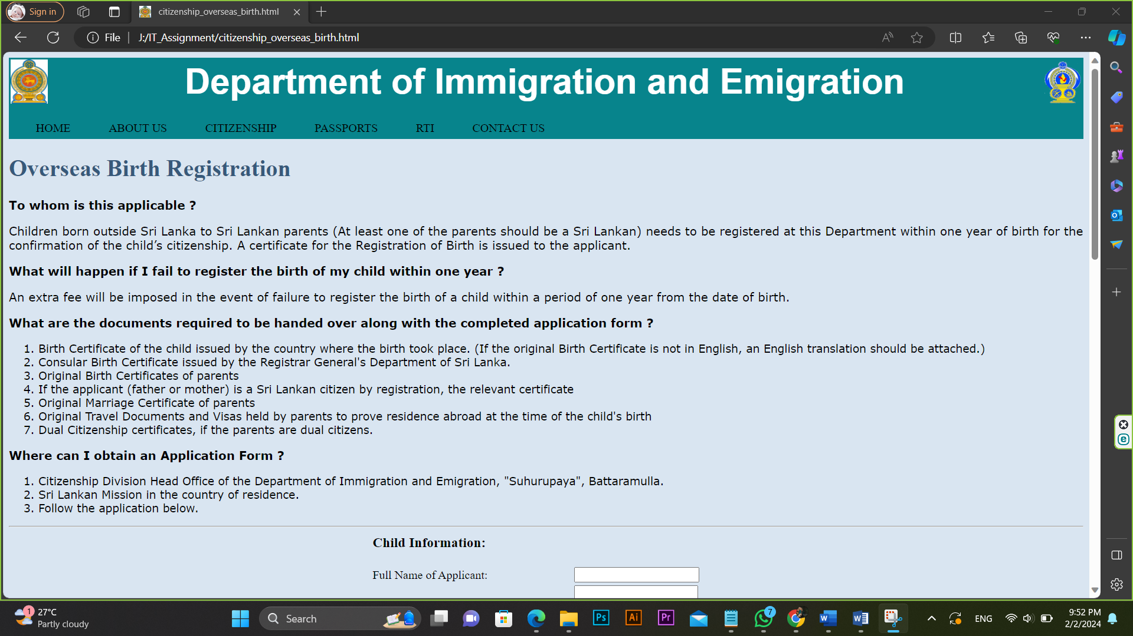

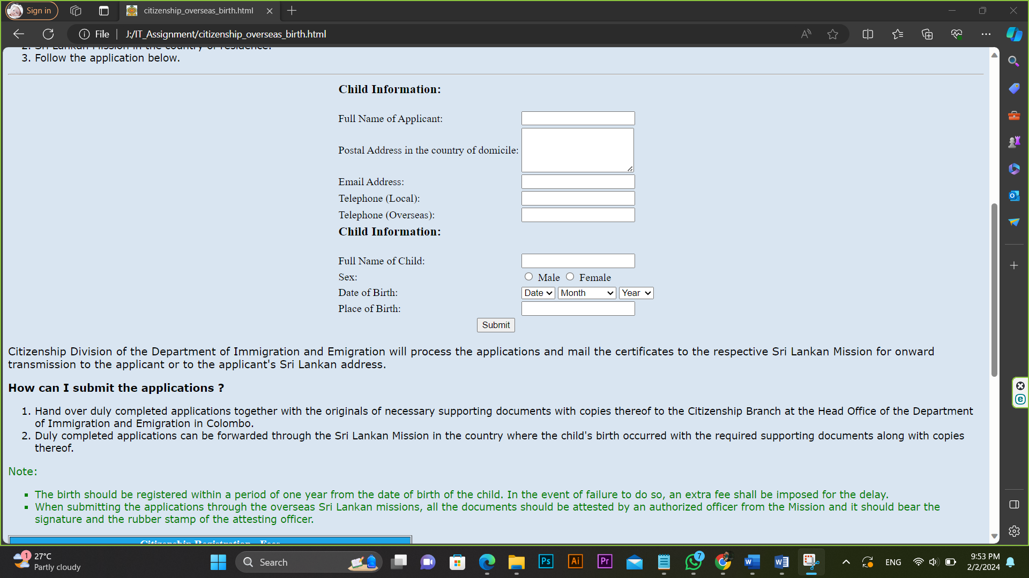

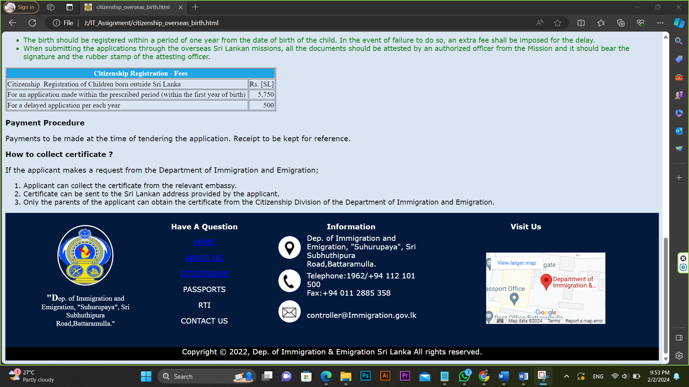

# 6.Passports page

# (Passport_Genaral_Info.html)

<html>

<head>

<title></title>

<link rel="icon" type="image/x-icon" href="OIP.jfif">

<link rel="stylesheet" type="text/css" href="cssdoc.css" />

</head>

<body>

<div class="header1">

<table width=100%>

<tr> <td><img src="OIP.jfif" width=50 height=60></td>

<td id="td1"><center><font size=10 color="white"><b>Department of Immigration and Emigration</b></font></center></td>

<td><img src="R.png" width=50 height=60 align="right"></td>

</tr>

</table>

</div>

<div class="header2">

<table cellpadding="10">

<tr> <td><div class="tab">

<a name="one">HOME</a>

<div class="sub-tabs">

<a href="Dashboard.html" class="sub-tab">Home</a>

</div>

</div></td>

<td><div class="tab">

<a name="two">ABOUT US</a>

<div class="sub-tabs">

<a href="vission_and_mission.html" class="sub-tab">Our vission & mission</a><br><br>

<a href="history.html" class="sub-tab">Department history</a>

</div>

</div></td>

<td><div class="tab">

<a name="three">CITIZENSHIP</a>

<div class="sub-tabs">

<a href="citizenship_genaral_information.html" class="sub-tab">General information</a><br><br>

<a href="citizenship_overseas_birth.html" class="sub-tab">Overseas birth registration</a>

</div>

</div></td>

<td><div class="tab">

PASSPORTS

<div class="sub-tabs">

<a href="Passport_Genaral_Info.html" class="sub-tab">General information</a>

</div>

</div></td>

<td><div class="tab">

RTI

<div class="sub-tabs">

<a href="RTI.html" class="sub-tab">RTI</a><br>

</div>

</div></td>

<td><div class="tab">

CONTACT US

<div class="sub-tabs">

<a href="contact_us.html" class="sub-tab">Contact details</a>

</div>

</div></td>

</tr>

</table>

</div>

<h1>General Information on Passports</h1>

<h4>New Passport application approval process</h4>

<p>With effect from 10th&nbsp; August 2015, applicants applying for passports are required to provide digital&nbsp;&nbsp; photograph and fingerprints to the Department. The digital photograph should be submitted through one of our&nbsp; Authorized photo studio located island-wide or at the Department Head Office or at Regional Offices. Printed photographs will no longer be accepted. Fingerprints will be collected at the Department Head Office or Regional Offices and applicant should be present in person.</p>

<p><strong>Important information:</strong></p>

<ol>

<li>All passport applicants irrespective of age should use passport Application</li>

<li>All passport applicants including children should provide digital photograph through Authorized photo studio</li>

<li>Fingerprints will be collected from all applicants between16 - 60 years at the Head Office and three Regional Offices in Sri Lanka</li>

<li>Applicants submitting passport applications through Sri Lanka Diplomatic Missions overseas could do so without providing fingerprints and digital photograph.</li>

<li>Inclusion of children in parents passport will NO longer be allowed and children will be issued separate passports</li>

</ol>

<p><strong>How to submit a digital photograph to the department</strong></p>

<ol>

<li>Visit a Authorized photo studio of your choice to obtain a digital photograph.&nbsp;Only the photos which were taken within 6 months will be valid.</li>

<li>Studio will send your photograph online to our computer system and will issue a Studio Acknowledgement Note to you. No printed photographs are required for passport application.</li>

<li>Studio acknowledgement note must be presented with your application and other supporting documents to the Department.</li>

</ol>

<p><strong>More information :</strong> Hotline 1962 or telephone numbers +94 112 101 500</p>

<p><strong>Am I eligible for a Sri Lankan Passport ?</strong></p>

<p>You can obtain a Sri Lankan Passport if you are – A Sri Lankan Citizen by descent or by registration.</p>

<p><strong>Getting passport urgently</strong></p>

<p>If you need your passport for urgent traveling you can apply for one-day service. This service is only available at Immigration &amp; Emigration Department Head Office.</p>

<p><strong>Validity Period of a Passport</strong></p>

<p>Currently issuing N series passports are valid 10 years unless otherwise specified. Validity period of passports for minors below 16 years of age is 03 years or 10 years as per the request of parents. Emergency Certificates are valid two (02) years but can be extended for further two years.</p>

<p><strong>What are the Working Hours ?</strong></p>

<p>We accept</p>

<ul>

<li>Normal Processing Applications - from 8.00 a.m. to 12.00 noon.</li>

<li>Urgent Basis Applications - from 7.00 a.m. to 12.00 noon.&nbsp;</li>

<li>Counter of Online Issues - &nbsp;from 8.00 a.m. to 12.00 noon.<br>

<em>The office closes on weekends and Public Holidays.</em></li>

</ul>

<p><strong>How do I apply for a passport ?</strong></p>

<p>You can submit all passport applications to the Passport Division (Level 01 - Normal Service&nbsp;/ Level 02 - Urgent Service) of the Department of Immigration &amp; Emigration located at "Suhurupaya", Battaramulla.</p>

<p><strong>What are the types of passports ?</strong></p>

<ol>

<li>A Passport valid for all countries

<ul>

<li>Ordinary Passport</li>

<li>Diplomatic passport</li>

<li>Official passport</li>

</ul>

</li>

<li>Emergency Certificates for Buddhist Pilgrims travel India and Nepal</li>

<li>ICOM &amp; NMRP for urgent one way travel document issued by Sri Lankan Overseas Missions</li>

</ol>

<h4 style="color:brown;"><br>

<span style="color:#000000;">Acquiring Biometric Data into the Passport System</span></h4>

<p>The Government of Sri Lanka has decided to obtain fingerprints as biometric data of applicants when issuing Passports with effect from 10th August 2015. Arrangements have also been made to obtain photographs of the applicants, conforming to standards of the International Civil Aviation Organization. By this arrangement, Sri Lankan Passport will become a travel document with international recognition.</p>

<p><strong>Important information of new passports issuance procedure.</strong></p>

<p><strong>Submitting Application</strong></p>

<ol>

<li>The

<li>Those application forms could be obtained from the Office of The Department, Regional Offices at Matara, Kandy,&nbsp;Vavuniya and Kurunegala. District Secretariats Offices, Divisional Secretariats Offices or from the website www.immigration.gov.lk.</li>

<li>As the fingerprints have to be captured, all applicants have to come in person to the Head Office of the Department or&nbsp; Regional Offices to submit their applications.</li>

</ol>

<p><strong>Photograph conforming to international standards</strong></p>

<ol>

<li>The Department will not accept printed photographs. All applicants should obtain their photographs only from studios authorized by the Department located island-wide or from studios established at the Head Office and Regional Offices of the Department.</li>

<li>The relevant studios will not give a printed photograph and your photograph will be forwarded to the data system of the Department through online technology.</li>

<li>The studio will issue you a acknowledgement note which should be submitted along with your application.</li>

<li>The list of authorized studios will be published in the newspapers and on our website www.immigration.gov.lk and will also be exhibited at District Secretariat Offices and Divisional Secretariat Offices.</li>

</ol>

<p><strong>Fingerprints</strong></p>

<ol>

<li>According to the provisions of the Immigration and Emigration Act No. 20 of 1948 amended by Act No. 7 of 2015 every applicant above 16 years of age and below 60 years of age must provide his or her fingerprints. Fingerprints will be obtained only at the Head Office and Regional Offices.</li>

</ol>

<p style="color:green;"><strong>Important</strong></p>

<p style="color:green;">Children below 16 years of age will hereafter not be included in the Passports of their parents and separate passports must be obtained for them.</p>

<p>More information: Hotline 1962 or telephone numbers +94 112 101 500</p>

<p><b><u>Special Note</u></b></p>

<p><b>New regulation imposed by the Finland Government for Sri Lankan Visa Applicants</b></p>

<p>Applicants who wish to apply visa for Finland shall take the following facts in to consideration, too.</p>

<ul>

<li>The Embassy of Finland is no longer allowed to approve Sri Lankan Passports where there are alterations of the name on the second page as per the new procedure introduced by the Ministry of Foreign Affairs in Finland.</li>

<li>The Mission is not authorized to accept the applications If there are any name alterations in the visa or resident permit applicants’ passports and such applicants should submit a new passport with the correct name.</li>

<li>The approval will be given for the passports that the name is written on the second page due to the reason that the name is too long to be written on the first page of the passport.</li>

</ul>

<div class="footer1"><br>

<table align="center" style="width:90%">

<tr>

<td rowspan=2 style="text-align:center;width:15%;">

<img class="img1" src="R.png" width="120" height="130"><br><p class="p1" style="font-family:Angsana New; color:white;">

"Dep. of Immigration and Emigration, "Suhurupaya", Sri Subhuthipura Road,Battaramulla."</p></td>

<td style="text-align:center;width:23%;"><p style="font-weight:bold; color:white;">Have A Question</p></td>

<td style="width:20%;"><p style="font-weight:bold; color:white; text-align:center;">Information</p></td>

<td style="text-align:center;width:32%;"><p style="font-weight:bold; color:white;">Visit Us</p></td>

</tr>

<tr>

<td><center><a href="#one"><p>HOME</p></a>

<a href="#two"><p>ABOUT US</p></a>

<a href="#three"><p>CITIZENSHIP</p></a>

<a style="color:white;text-decoration:none;" href="Passport_Genaral_Info.html"><p>PASSPORTS</p></a>

<a style="color:white;text-decoration:none;" href="RTI.html"><p>RTI</p></a>

<a style="color:white;text-decoration:none;" href="contact_us.html"><p>CONTACT US</p></a>

</center></td>

<td> <table>

<tr>

<td>

<ul class="list1">

<li class="icon1"></li>

</ul></td>

<td>

<p style="color:white;">

Dep. of Immigration and Emigration, "Suhurupaya", Sri Subhuthipura Road,Battaramulla.

</p></td>

</tr>

<tr>

<td>

<ul class="list1">

<li class="icon2"></li>

</ul></td>

<td>

<p style="color:white;">Telephone:1962/+94 112 101 500<br>

Fax:+94 011 2885 358</p>

</tr>

<tr>

<td>

<ul class="list1">

<li class="icon3"></li>

</ul></td>

<td>

<p style="color:white;">controller@Immigration.gov.lk</p>

</tr>

</table>

</td>

<td>

<div class="gmap">

<iframe src="https://www.google.com/maps/embed?pb=!1m18!1m12!1m3!1d495.1131308234952!2d79.9220707648389!3d6.901958164654896!2m3!1f0!2f0!3f0!3m2!1i1024!2i768!4f13.1!3m3!1m2!1s0x3ae2590ae37765f1%3A0x1dbb558b4ad5ebad!2sDepartment%20of%20Immigration%20%26%20Emigration!5e0!3m2!1sen!2slk!4v1706818538948!5m2!1sen!2slk" width="100%" height="50%" style="border:0;" allowfullscreen="" loading="lazy" referrerpolicy="no-referrer-when-downgrade">

</iframe>

</div>

</td>

</tr>

</table>

</div>

<div style="background-color:black; width:100%; height: 30px;">

<div class="footer2">

<p style="color: white;text-align:center;">Copyright © 2022, Dep. of Immigration & Emigration Sri Lanka All rights reserved.</p>

</div>

</div>

</body>

</html>

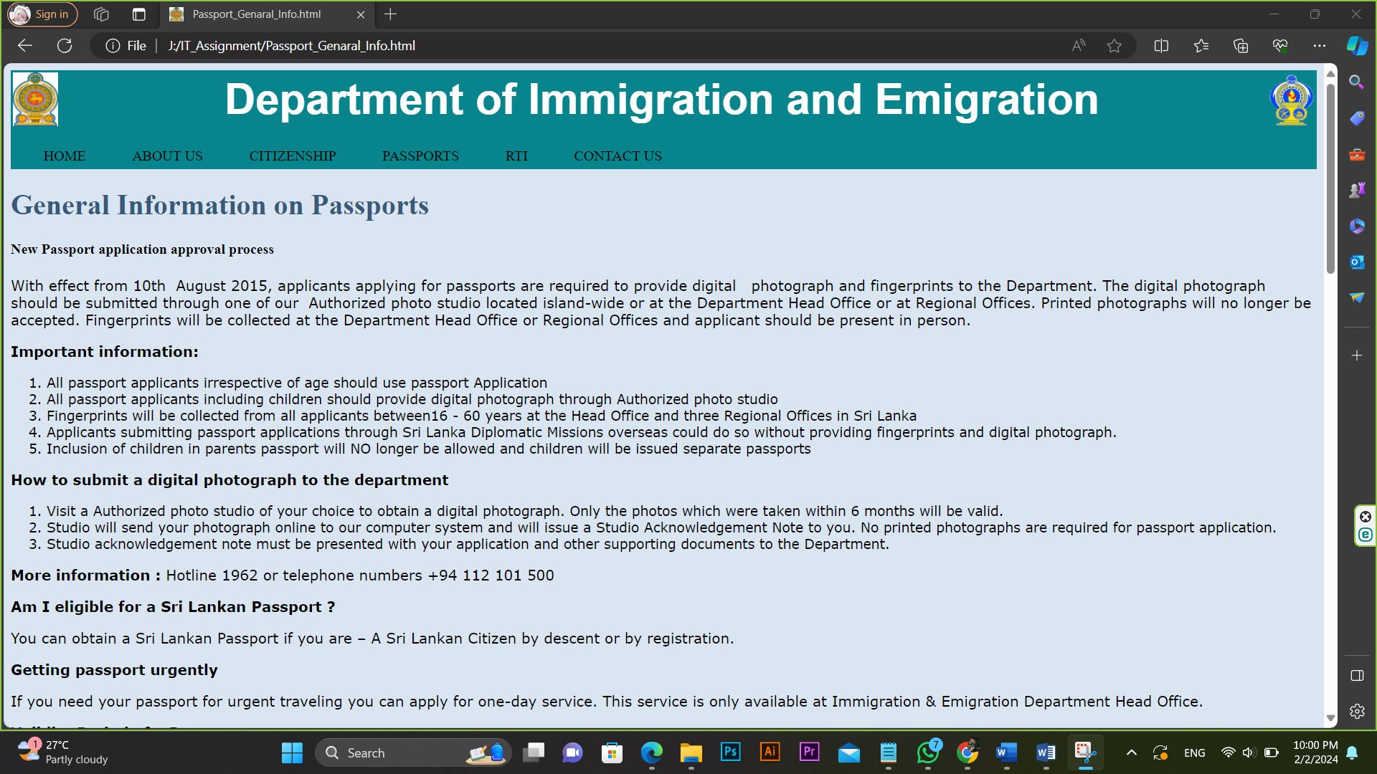

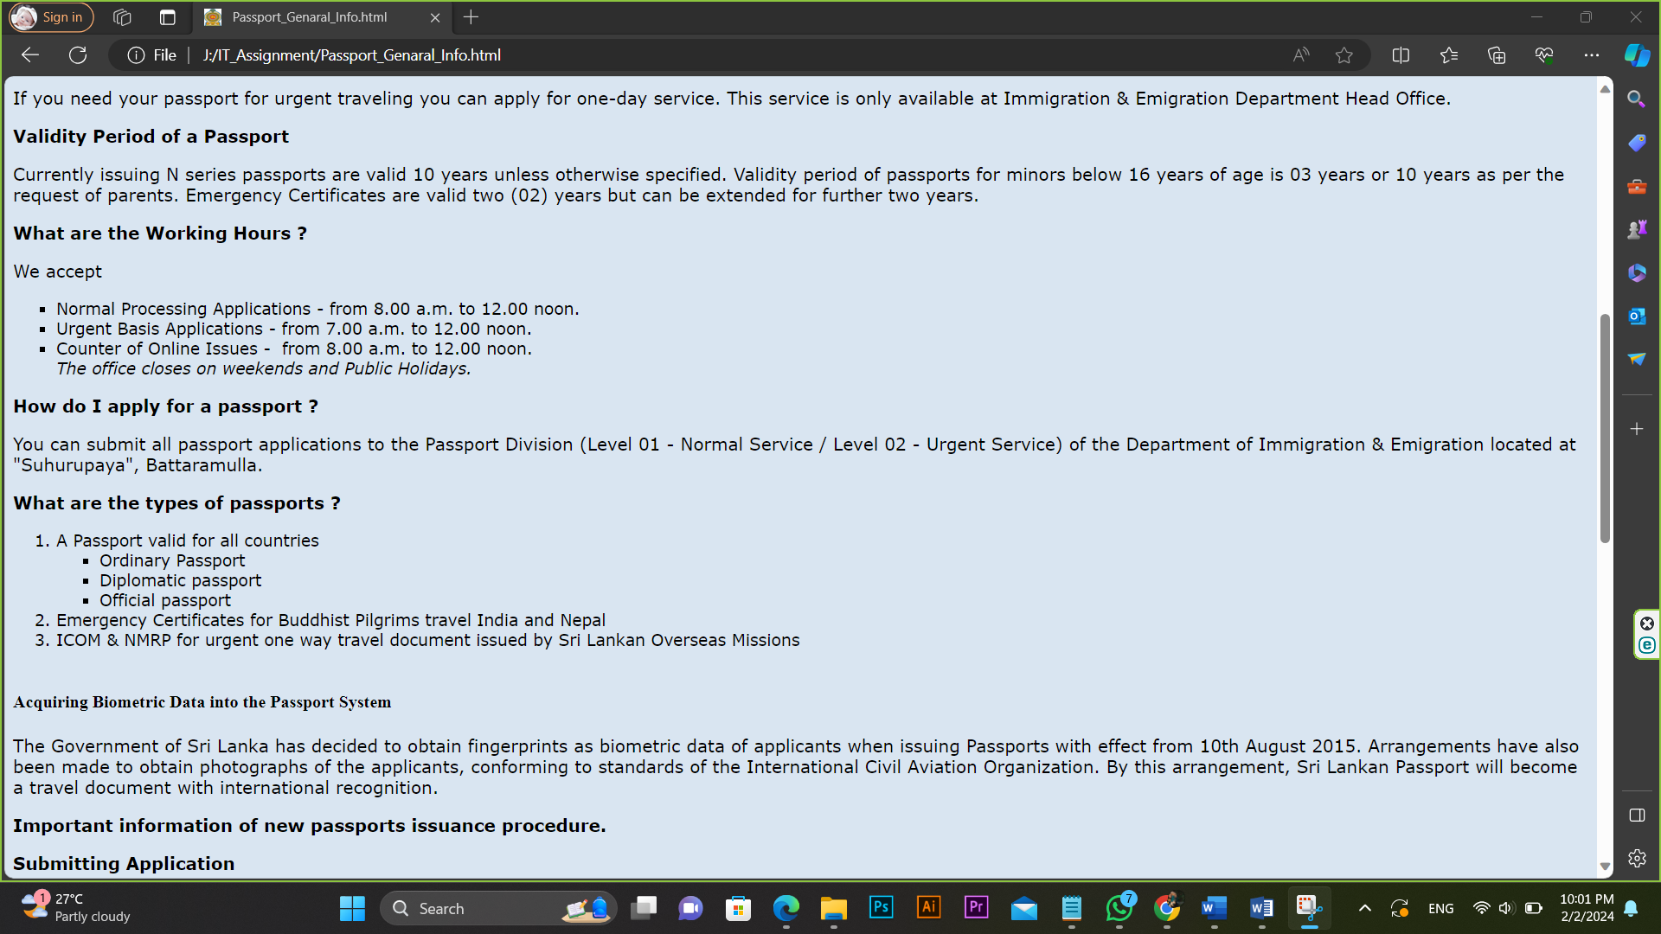

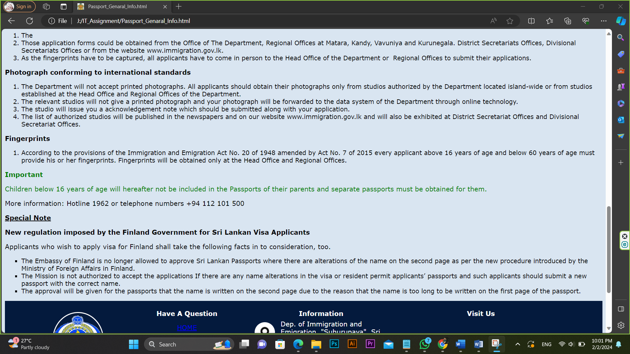

# 7.RTI page (RTI.html)

<html>

<head>

<title></title>

<link rel="icon" type="image/x-icon" href="OIP.jfif">

<link rel="stylesheet" type="text/css" href="cssdoc.css" />

<style> input:focus {background-color:#20a6e8;}

textarea:focus {background-color:#20a6e8;}

</style>

</head>

<body>

<div class="header1">

<table width=100%>

<tr> <td><img src="OIP.jfif" width=50 height=60></td>

<td id="td1"><center><font size=10 color="white"><b>Department of Immigration and Emigration</b></font></center></td>

<td><img src="R.png" width=50 height=60 align="right"></td>

</tr>

</table>

</div>

<div class="header2">

<table cellpadding="10">

<tr> <td><div class="tab">

<a name="one">HOME</a>

<div class="sub-tabs">

<a href="Dashboard.html" class="sub-tab">Home</a>

</div>

</div></td>

<td><div class="tab">

<a name="two">ABOUT US</a>

<div class="sub-tabs">

<a href="vission_and_mission.html" class="sub-tab">Our vission & mission</a><br><br>

<a href="history.html" class="sub-tab">Department history</a>

</div>

</div></td>

<td><div class="tab">

<a name="three">CITIZENSHIP</a>

<div class="sub-tabs">

<a href="citizenship_genaral_information.html" class="sub-tab">General information</a><br><br>

<a href="citizenship_overseas_birth.html" class="sub-tab">Overseas birth registration</a>

</div>

</div></td>

<td><div class="tab">

PASSPORTS

<div class="sub-tabs">

<a href="Passport_Genaral_Info.html" class="sub-tab">General information</a>

</div>

</div></td>

<td><div class="tab">

RTI

<div class="sub-tabs">

<a href="RTI.html" class="sub-tab">RTI</a><br>

</div>

</div></td>

<td><div class="tab">

CONTACT US

<div class="sub-tabs">

<a href="contact_us.html" class="sub-tab">Contact details</a>

</div>

</div></td>

</tr>

</table>

</div>

<center><h2>Application to Receive Information</h2>

<table>

<form action="#" method="post" enctype="multipart/form-data">

<tr>

<td><label for="requestor_name">Name of Requestor:</label></td>

<td><input type="text" id="requestor_name" name="requestor_name"></td>

</tr>

<tr>

<td><label for="address">Address (if any):</label></td>

<td><input type="text" id="address" name="address"></td>

</tr>

<tr>

<td><label for="contact_number">Contact Number:</label></td>

<td><input type="text" id="contact_number" name="contact_number"></td>

</tr>

<tr>

<td><label for="email">Email Address (if any):</label></td>

<td><input type="email" id="email" name="email"></td>

</tr>

<tr>

<td colspan="2"><label for="info_details">Details about information request:</label></td>

</tr>

<tr>

<td><label for="specific_authority">I. Specific Public Authority:</label></td>

<td><input type="text" id="specific_authority" name="specific_authority"></td>

</tr>

<tr>

<td><label for="info_requested">II. Information Requested:</label></td>

<td><input type="text" id="info_requested" name="info_requested"></td>

</tr>

<tr>

<td>Attachments (.jpg / .png / .gif / .doc / .docx / .xls / .xlsx ): </td>

<td><input type="file" id="attachments" name="attachments"></td>

</tr>

<tr>

<td><label for="specific_period">III. Specific period information is requested (if applicable):</label></td>

<td><input type="text" id="specific_period" name="specific_period"></td>

</tr>

<tr>

<td><label for="language">Language in which requestor access:</label></td>

<td>

<select id="language" name="language">

<option value="" disabled selected>-- Please select a language --</option>

<option value="English">English</option>

<option value="Sinhala">Sinhala</option>

<option value="Tamil">Tamil</option>

</select>

</td>

</tr>

<tr>

<td><label for="concern_life">Does the information request concern the life and personal liberty:</label></td>

<td>

<input type="radio" id="yes" name="concern_life" value="YES">

<label for="yes">YES</label>

<input type="radio" id="no" name="concern_life" value="NO">

<label for="no">NO</label>

</td>

</tr>

<tr>

<td><label for="reason_belief">If yes, give reason for belief:</label></td>

<td><input type="text" id="reason_belief" name="reason_belief"></td>

</tr>

<tr>

<td><label for="other_details">Any other details:</label></td>

<td><textarea id="other_details" name="other_details" rows="4" cols="50"></textarea></td>

</tr>

<tr>

<td><label for="citizen_srilanka">Is the requestor a citizen of Sri Lanka:</label></td>

<td>

<input type="radio" id="citizen_yes" name="citizen_srilanka" value="YES">

<label for="citizen_yes">YES</label>

<input type="radio" id="citizen_no" name="citizen_srilanka" value="NO">

<label for="citizen_no">NO</label>

</td>

</tr><br><br>

<tr>

<td colspan="2"><center>

<input type="submit" value="Submit"> &nbsp;&nbsp;&nbsp;

<input type="reset" value="Clear"></center>

</td>

</tr>

</form>

</table></center>

<div class="footer1"><br>

<table align="center" style="width:90%">

<tr>

<td rowspan=2 style="text-align:center;width:15%;">

<img class="img1" src="R.png" width="120" height="130"><br><p class="p1" style="font-family:Angsana New; color:white;">

"Dep. of Immigration and Emigration, "Suhurupaya", Sri Subhuthipura Road,Battaramulla."</p></td>

<td style="text-align:center;width:23%;"><p style="font-weight:bold; color:white;">Have A Question</p></td>

<td style="width:20%;"><p style="font-weight:bold; color:white; text-align:center;">Information</p></td>

<td style="text-align:center;width:32%;"><p style="font-weight:bold; color:white;">Visit Us</p></td>

</tr>

<tr>

<td><center><a href="#one"><p>HOME</p></a>

<a href="#two"><p>ABOUT US</p></a>

<a href="#three"><p>CITIZENSHIP</p></a>

<a style="color:white;text-decoration:none;" href="Passport_Genaral_Info.html"><p>PASSPORTS</p></a>

<a style="color:white;text-decoration:none;" href="RTI.html"><p>RTI</p></a>

<a style="color:white;text-decoration:none;" href="contact_us.html"><p>CONTACT US</p></a>

</center></td>

<td> <table>

<tr>

<td>

<ul class="list1">

<li class="icon1"></li>

</ul></td>

<td>

<p style="color:white;">

Dep. of Immigration and Emigration, "Suhurupaya", Sri Subhuthipura Road,Battaramulla.

</p></td>

</tr>

<tr>

<td>

<ul class="list1">

<li class="icon2"></li>

</ul></td>

<td>

<p style="color:white;">Telephone:1962/+94 112 101 500<br>

Fax:+94 011 2885 358</p>

</tr>

<tr>

<td>

<ul class="list1">

<li class="icon3"></li>

</ul></td>

<td>

<p style="color:white;">controller@Immigration.gov.lk</p>

</tr>

</table>

</td>

<td>

<div class="gmap">

<iframe src="https://www.google.com/maps/embed?pb=!1m18!1m12!1m3!1d495.1131308234952!2d79.9220707648389!3d6.901958164654896!2m3!1f0!2f0!3f0!3m2!1i1024!2i768!4f13.1!3m3!1m2!1s0x3ae2590ae37765f1%3A0x1dbb558b4ad5ebad!2sDepartment%20of%20Immigration%20%26%20Emigration!5e0!3m2!1sen!2slk!4v1706818538948!5m2!1sen!2slk" width="100%" height="50%" style="border:0;" allowfullscreen="" loading="lazy" referrerpolicy="no-referrer-when-downgrade">

</iframe>

</div>

</td>

</tr>

</table>

</div>

<div style="background-color:black; width:100%; height: 30px;">

<div class="footer2">

<p style="color: white;text-align:center;">Copyright © 2022, Dep. of Immigration & Emigration Sri Lanka All rights reserved.</p>

</div>

</div>

</body>

</html>

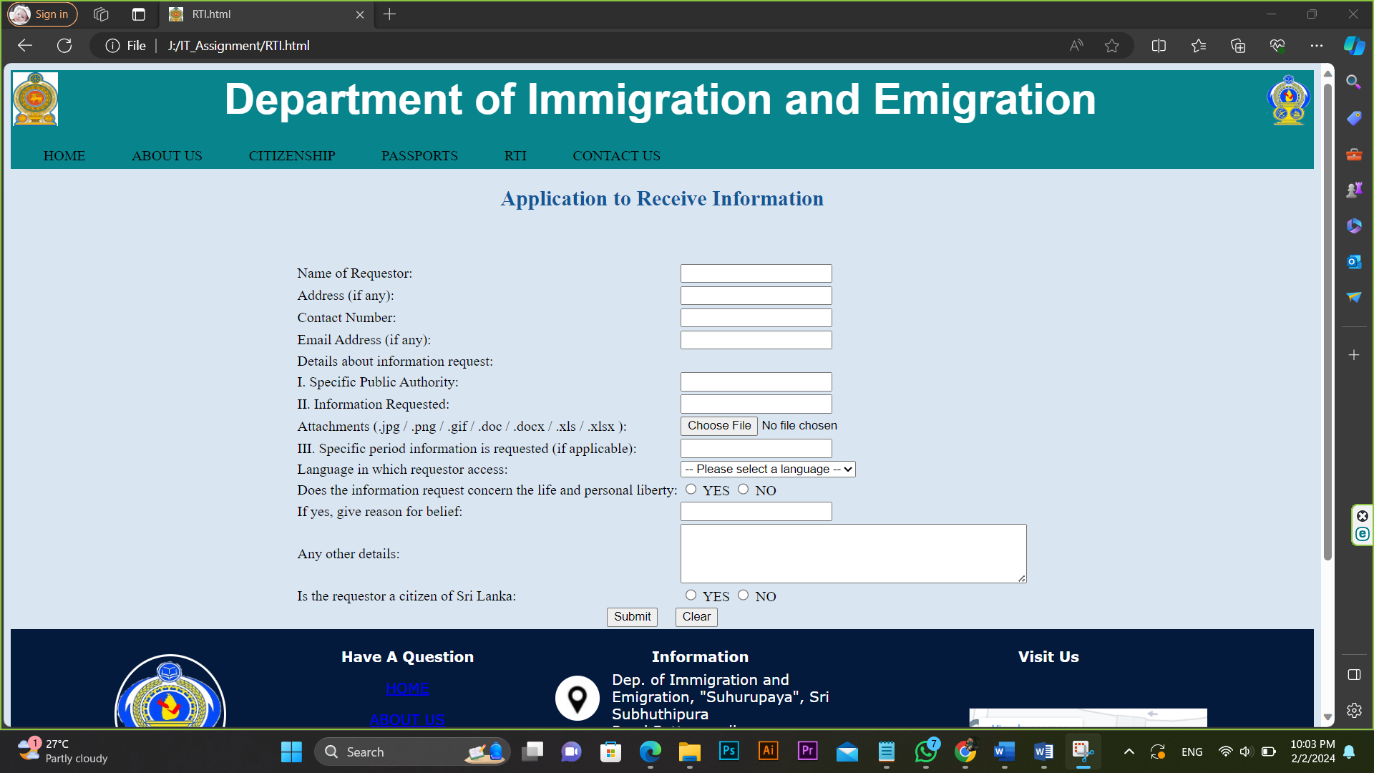

# 8.Contact us page (contact_us.html)

<html>

<head>

<title></title>

<link rel="icon" type="image/x-icon" href="OIP.jfif">

<link rel="stylesheet" type="text/css" href="cssdoc.css" />

<style>

</style>

</head>

<body>

<div class="header1">

<table width=100%>

<tr> <td><img src="OIP.jfif" width=50 height=60></td>

<td id="td1"><center><font size=10 color="white"><b>Department of Immigration and Emigration</b></font></center></td>

<td><img src="R.png" width=50 height=60 align="right"></td>

</tr>

</table>

</div>

<div class="header2">

<table cellpadding="10">

<tr> <td><div class="tab">

<a name="one">HOME</a>

<div class="sub-tabs">

<a href="Dashboard.html" class="sub-tab">Home</a>

</div>

</div></td>

<td><div class="tab">

<a name="two">ABOUT US</a>

<div class="sub-tabs">

<a href="vission_and_mission.html" class="sub-tab">Our vission & mission</a><br><br>

<a href="history.html" class="sub-tab">Department history</a>

</div>

</div></td>

<td><div class="tab">

<a name="three">CITIZENSHIP</a>

<div class="sub-tabs">

<a href="citizenship_genaral_information.html" class="sub-tab">General information</a><br><br>

<a href="citizenship_overseas_birth.html" class="sub-tab">Overseas birth registration</a>

</div>

</div></td>

<td><div class="tab">

PASSPORTS

<div class="sub-tabs">

<a href="Passport_Genaral_Info.html" class="sub-tab">General information</a>

</div>

</div></td>

<td><div class="tab">

RTI

<div class="sub-tabs">

<a href="RTI.html" class="sub-tab">RTI</a><br>

</div>

</div></td>

<td><div class="tab">

CONTACT US

<div class="sub-tabs">

<a href="contact_us.html" class="sub-tab">Contact details</a>

</div>

</div></td>

</tr>

</table>

</div>

<h2>Location</h2>

<br>

<iframe src="https://www.google.com/maps/embed?pb=!1m18!1m12!1m3!1d495.1131308234952!2d79.9220707648389!3d6.901958164654896!2m3!1f0!2f0!3f0!3m2!1i1024!2i768!4f13.1!3m3!1m2!1s0x3ae2590ae37765f1%3A0x1dbb558b4ad5ebad!2sDepartment%20of%20Immigration%20%26%20Emigration!5e0!3m2!1sen!2slk!4v1706818538948!5m2!1sen!2slk" width="100%" height="50%" style="border:0;" allowfullscreen="" loading="lazy" referrerpolicy="no-referrer-when-downgrade">

</iframe>

<hr>

<h2>Contact Details</h2>

<p><strong>Department of Immigration and Emigration</strong></p>

<p><span style="font-size:12px;">"Suhurupaya", Sri Subhuthipura Road, Battaramulla. </span></p>

<p>Hotline : 1962</p>

<p>Phone : +94 112 101 500<br>

<br>

Fax : +94 11 2885358</p>

<p>E-Mail : controller@immigration.gov.lk</p>

<p>Web Site: <a href="https://www.immigration.gov.lk/">www.immigration.gov.lk</a></p>

<table><tr><td s style="width: 33.33%;">

<p><strong>Controller General of Immigration and Emigration,</strong>&nbsp;<br>

Commissioner for Registration of Persons of Indian Origin &amp;<br>

Designated Officer&nbsp;(Right to Information Act)</p>

<img alt="Mr. I. S. H. J. Ilukpitiya" src="6280.jpg" style="width: 110px; height: 141px;">

<p>Mr. I. S. H. J. Ilukpitiya</p>

<p><strong>Telephone</strong> : +94 11 2 101551</p>

<p><strong>Fax :</strong> +94 11 2885358</p>

<p><strong>Email :</strong> controller@immigration.gov.lk</p>

</td>

<td s style="width: 33.33%;">

<p><strong>Additional Controller General</strong></p>

<img alt="Mr. M. A. P. Imal Gunawardena" src="6312.jpg" style="width: 110px; height: 141px;">

<p>Mr. M. A. P. Imal Gunawardena</p>

<p><strong>Telephone</strong> : +94 11 2 101552</p>

</td>

<td s style="width: 33.33%;">

<p><strong>Information Officer (</strong><strong>Right to Information Act)</strong></p>

<img alt="" src="6213.jpg" style="width: 110px; height: 141px;"></div>

<p>Ms. K. M. S. M. Chathurangi - Deputy Controller (Legal)</p>

<p><strong>Telephone</strong>&nbsp;: +94 11 2 101569</p>

<p>Email : dieaclegal@gmail.com</p>

</td>

</tr>

</table>

<div class="footer1"><br>

<table align="center" style="width:90%">

<tr>

<td rowspan=2 style="text-align:center;width:15%;">

<img class="img1" src="R.png" width="120" height="130"><br><p class="p1" style="font-family:Angsana New; color:white;">

"Dep. of Immigration and Emigration, "Suhurupaya", Sri Subhuthipura Road,Battaramulla."</p></td>

<td style="text-align:center;width:23%;"><p style="font-weight:bold; color:white;">Have A Question</p></td>

<td style="width:20%;"><p style="font-weight:bold; color:white; text-align:center;">Information</p></td>

<td style="text-align:center;width:32%;"><p style="font-weight:bold; color:white;">Visit Us</p></td>

</tr>

<tr>

<td><center><a href="#one"><p>HOME</p></a>

<a href="#two"><p>ABOUT US</p></a>

<a href="#three"><p>CITIZENSHIP</p></a>

<a style="color:white;text-decoration:none;" href="Passport_Genaral_Info.html"><p>PASSPORTS</p></a>

<a style="color:white;text-decoration:none;" href="RTI.html"><p>RTI</p></a>

<a style="color:white;text-decoration:none;" href="contact_us.html"><p>CONTACT US</p></a>

</center></td>

<td> <table>

<tr>

<td>

<ul class="list1">

<li class="icon1"></li>

</ul></td>

<td>

<p style="color:white;">

Dep. of Immigration and Emigration, "Suhurupaya", Sri Subhuthipura Road,Battaramulla.

</p></td>

</tr>

<tr>

<td>

<ul class="list1">

<li class="icon2"></li>

</ul></td>

<td>

<p style="color:white;">Telephone:1962/+94 112 101 500<br>

Fax:+94 011 2885 358</p>

</tr>

<tr>

<td>

<ul class="list1">

<li class="icon3"></li>

</ul></td>

<td>

<p style="color:white;">controller@Immigration.gov.lk</p>

</tr>

</table>

</td>

<td>

<div class="gmap">

<iframe src="https://www.google.com/maps/embed?pb=!1m18!1m12!1m3!1d495.1131308234952!2d79.9220707648389!3d6.901958164654896!2m3!1f0!2f0!3f0!3m2!1i1024!2i768!4f13.1!3m3!1m2!1s0x3ae2590ae37765f1%3A0x1dbb558b4ad5ebad!2sDepartment%20of%20Immigration%20%26%20Emigration!5e0!3m2!1sen!2slk!4v1706818538948!5m2!1sen!2slk" width="100%" height="50%" style="border:0;" allowfullscreen="" loading="lazy" referrerpolicy="no-referrer-when-downgrade">

</iframe>

</div>

</td>

</tr>

</table>

</div>

<div style="background-color:black; width:100%; height: 30px;">

<div class="footer2">

<p style="color: white;text-align:center;">Copyright © 2022, Dep. of Immigration & Emigration Sri Lanka All rights reserved.</p>

</div>

</div>

</body>

</html>

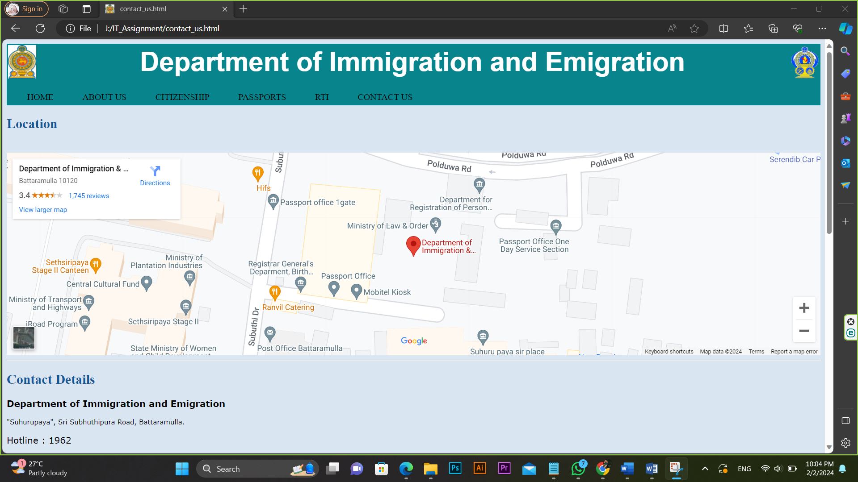

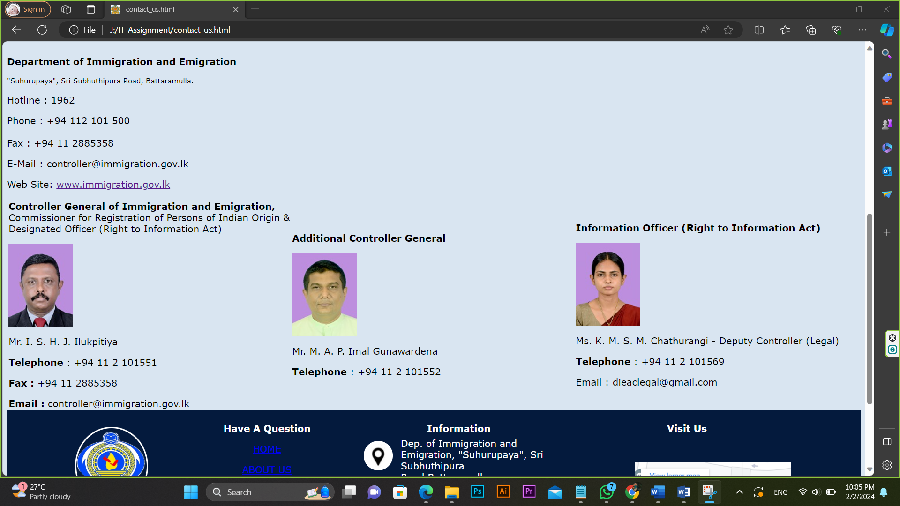

# 9.CSS (cssdoc.css)

div.header1 {background-color:#07848c;

height:50px;

font-family:Arial;}

div.header2 {background-color:#07848c;

padding:10px;

height:40px;

display: flex;}

.tab:hover {background-color: #900C3F;

color: white;}

.tab {padding: 10px;

margin: 5px;

position: relative;}

.sub-tabs {display: none;

position: absolute;

top: 100%;

left: 0;

width: 100%;

background-color: rgba(255, 255, 255, 0.8);

border: 1px solid #ccc;

padding: 10px;}

.tab:hover .sub-tabs {display: block;

color:red;

background-color: transparent;

background-color:white;}

.sub-tab {margin: 5px;

background-color: transparent;

cursor: pointer;}

body {

background-color: #D9E5F1 ;

}

h1 {

color: #37597A ;

}

h2 {

color: #135798;

}

ul {

list-style-type: square;

font-family: verdana;

font-size: 15px;

}

ol {

list-style-type: 1;

font-family: verdana;

font-size: 15px;

}

p {

font-family: verdana;

font-size: 15px;

}

p.p1::first-letter {font-weight:bold;

font-size:20px;}

div.footer1 {background-color:#041a3d;

width:100%;

height:300px;}

img.img1 {border-radius:50%;

border: 3px solid white;}

.list1 {list-style: none;

padding: 0;}

.list1 li {width: 50px;

height: 50px;

margin-right: 10px;

background-image: url('image09.jpg');

background-repeat: no-repeat;}

.list1 .icon1 {background-position:-52px -3px;

border-radius: 50%;}

.list1 .icon2 {background-position:-201px -3px;

border-radius: 50%;}

.list1 .icon3 {background-position:-248px -3px;

border-radius: 50%;}

.gmap {padding-bottom: 40%;

position: relative;}

.gmap iframe {height: 90%;

width: 60%;

left: 0;

top: 0;

position: absolute;

transform: translate(50%, 15%);}

.footer2 {width: 700px;

height: 15px;

margin: auto;

padding:20px;

transform: translate(0%, -65%);}